Survey on Applicant Investment in Grants.gov

Executive Summary and Survey Results

Prepared by the Federal Demonstration Partnership eRA Committee

Committee Members
Kellie Guentert, Executive Editor
Susan Ross
Mark Sweet
Tye Rougas
Steve Dowdy
Kim Deutsch
Tom Drinane
Bob Beattie
Ron Splittgerber

Executive Summary

Section 1. Introduction
On November 20, 1999, the Federal Financial Assistance Management Improvement Act (PL 106-107) was signed into law. As a result of this act, Federal agencies, under OMB management, worked together to help streamline the grants submission process for grantees by providing a common portal -- Grants.gov -- to publish opportunities and accept applications.
The portal is funded by an agreement between the agencies, each contributing a portion of its budget.
In the spring of 2009, with the influx of large numbers of ARRA grants, the capacity of the Grants.gov submission process was questioned. In response to a perceived problem, the Director of OMB reversed early policy and allowed agencies to use other systems for grants submission. Some agencies immediately pulled back from Grants.gov and required use of their own idiosyncratic systems.
Neither the OMB nor the agencies seem to consider the large investment that grant seeking organizations have made to adapt their internal grants management systems to Grants.gov; for both forms use and system to system.
The purpose of this survey is to determine how large an investment FDP members have made to support Grants.gov submissions.
Investment in Grants.gov can take a number of forms such as creating and maintaining a System to System program, training staff and faculty on how to manage Adobe Forms, purchasing new hardware and software for forms submission, and changing business practices, among others. The following questions attempt to ascertain how much investment we all have made in Grants.gov.
We will present the results at an FDP meeting as well as post them to the FDP website and share with Grants.gov PMO and appropriate government officials. If you have questions about this survey, do not hesitate to contact the FDP eRA Committee, at fdp-ps@csucipp.net

1. Please provide the following data. We need contact information to follow up if necessary. We will show the data publicly only in aggregate form, without reference to individual responses.
Name:
Organization:
Working Title:
Department:
City/Town:
State:
ZIP:
Email Address:
Phone Number:

2. Has your institution considered the System-to-System (S2S) potential of Grants.gov or do you plan to consider S2S in the future?

3. Are you now submitting applications via System to System?
Answers combined in question 4 below
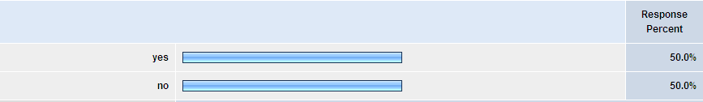

4. Pick the answer that most accurately describes your ability to submit to Grants.gov using S2S. Are you able to respond to most all available opportunities using S2S?
A survey of 56 FDP-member institutions found that 50% are currently submitting to Grants.gov via System to System (S2S). Of those institutions submitting via S2S, only 28.6% are able to respond to most available opportunities. The reasons for not submitting to all opportunities via S2S were commonly cited as the system or vendor only supports NIH applications or a subset of NIH applications. A few respondents pointed out that not all federal funding opportunities are available on Grants.gov or they are not available for S2S submission.
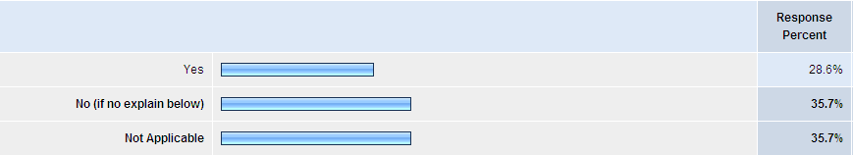

5. How has your institution dealt with the System-to-System (S2S) potential of Grants.gov? Please pick one option but feel free to provide additional commentary in the Comment box.
Most institutions (42.9%) have purchased an S2S system from a vendor. 19% are work with a consortium of institutions to use or develop an S2S system. A few institutions are working jointly with a vendor (4.8%) or have developed their own S2S system (4.8%) and 9.5% are in the process of determining how to proceed. A fair number, 11.9% are still in the process of assessing how S2S will benefit their institutions.
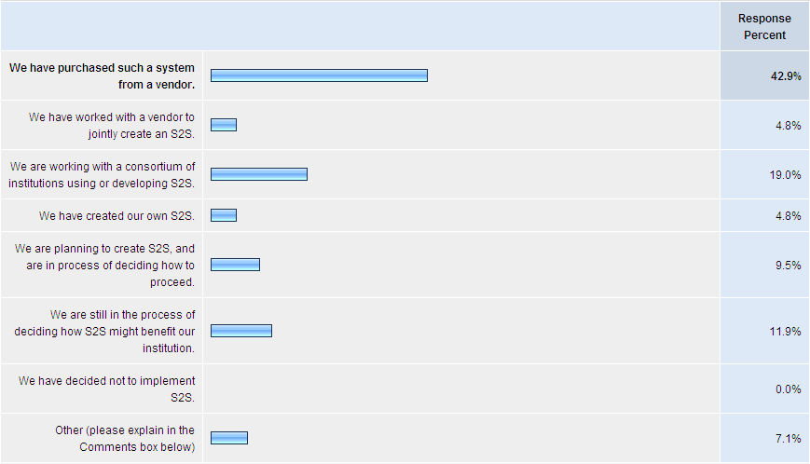

6. If you are working with a vendor, consortium or other organization on an S2S solution, please provide its name below.
There are several vendors or consortiums that provide S2S services. Most commonly used vendors were Cayuse, ERA Software Systems, and InfoEd. The consortium of Kuali and COEUS was also used by a number of institutions. The number of respondents using each S2S provider is listed below (n=34).

7. Compared to forms-based submission process (earlier PureEdge or now Adobe) please estimate any cost avoidance or savings by using Grants.gov S2S.
When asked to provide an estimate of the cost savings or avoidance by using Grants.gov S2S a majority of respondents said there was no savings (25.6%) or the question was not applicable (41.0%). Several other institutions indicated the cost savings as illustrated below:
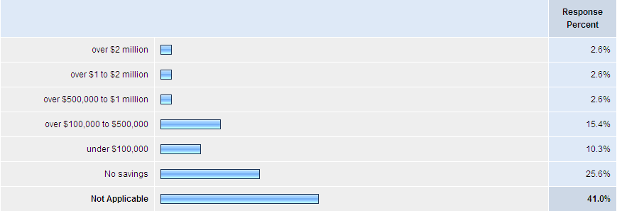
Explainations for cost savings or avoidance ranged from savings in reduced effort or elimination of duplicative efforts to streamlining submission and being able to submit on time. In addition, several institutitions commented that they do not yet have enough data to estimate the cost savings realized by implementing S2S.
8. What DUNS number is used for Grants.gov submissions for S2S? If you have more than one DUNS number you use for submissions, please list each one separated by a comma. (This number will not be published - it will be used to augment the statistical collection.)
The respondents listed over 30 DUNS numbers. Several schools indicated multiple DUNS numbers. Often, medical schools submit under a separate DUNS number from the main campus. Also, some universities systems are utilizing single solutions but submitting under multiple DUNS numbers for each campus.

9. Are you using you S2S to send all applications eligible for S2S submission?

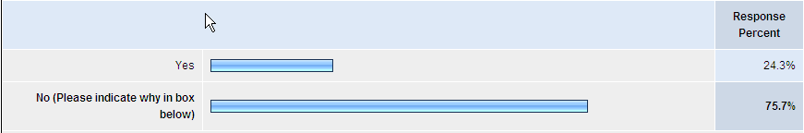

The respondents indicated various reasons why they do not utilize S2S for all transactions. The majority of the respondents indicated that they are still in development and/or implementation at this point while other indicated they are only utilizing their S2S solution for NIH at this time.
7 indicated they are still in development and/or implementation stage at this point
3 indicated that they only submit to NIH at this time while they continue to test, roll-out their solution to a broader audience.
2 indicated that their vendor solution only supports NIH at this time
3 indicated that they do not have mandate to use their S2S solution at this time and allow users to opt for agency solutions such as FastLane and NSPIRES.
4 are not S2S ready
3 indicated lack of technical resources or other technical issues at this time.

10. Why did you choose to invest in S2S?
Check all that apply
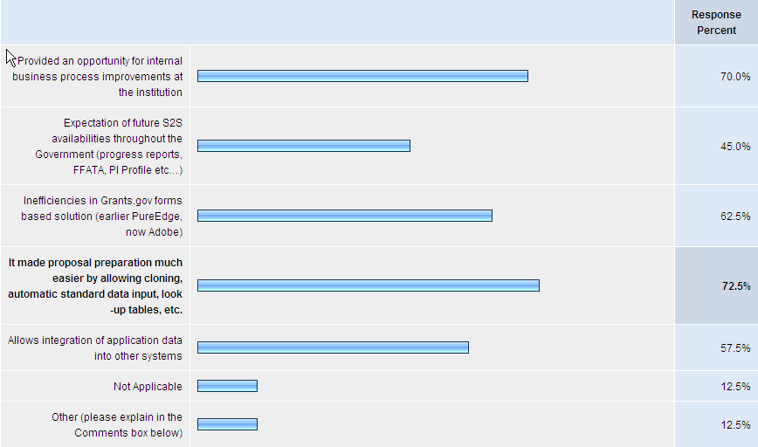

Comments included:
- We could build a S2S process because we already had integrated data from other systems into our internal grant management system.
- S2S allows for agency validation rules to be applied before application is submitted.
- Will make life easier for the faculty rather than using paper routing and entering data into two systems
- Reporting opportunities
- Keep our data on site
- One user interface for all sponsors
- It provides a most efficient auditing trail for both the internal and external auditors like NIH, FDA, etc...

12. Please estimate your one time, new costs for initial S2S: development and installation. If you are still in planning or development stages, estimate your development and implementation costs.
Investment estimate may include the selection process, hardware purchase, software purchase, maintenance fees, consulting fees, in-house staff effort, data conversion cost, testing, training, maintaining, additional time spent reviewing / troubleshooting / resubmitting applications and an institutional help desk. Please give any explanation you feel important in the Comments box.

The majority of the respondents (40%) indicated that their initial investment in S2S ranged from $100,000 to $500,000. The survey instrument made it difficult to analyses the exact breakout of costs. Some schools, for example, must train over a thousand faculty to utilize a new system. Therefore, the costs above ranged from selection, negotiation, license, training resource development, training, and help desk support.
Some schools have developed their own S2S solution while others have purchased vendor or consortium solutions. For example, one school indicated that Initial development took 6 months effort with 5 FTEs and approximately 2 FTEs for on-going enhancements and support. One school indicated approximately $1 million to develop with an on-going support.
Some respondents indicated that they will use an emerging open-source solution (therefore no license fees) but will still have the cost of implementation and training.

13. Please estimate your institution's annual expenses (including staffing) to maintain S2S.

Of the 32 responses to the “annual expenses to maintain S2S” question, only 22 are included in the analysis due to the other 8 either not knowing the cost or not currently having S2S in production to be able to determine the cost.
The 22 remaining responses ranged from $5,000 to 1,200,000. With the breakout as follows:
5,000-200,000 – 16 respondents 72.8%
200,001-300,000 – 0%
300,001-400,000 – 1 respondent 4.5%
400,001-500,000 – 4 respondents 18.2%
500,001 or more – 1 respondent 4.5%

14. Please estimated the number of FTE dedicated to S2S including all activities noted above.

Of the 32 responses to the “number of FTE dedicate to S2S” question, only 28 are included in the analysis due to the other 4 not yet knowing what their number of dedicated staff will be.
The 28 responses ranged from 0 FTE to 6 FTE dedicated to S2S. With the breakout as follows:
0 FTE (due to vendor supported/managed S2S or because existing staff had this added to their functions) – 4 respondents 14.29%
1 FTE or less – 7 respondents 25%
1-2 FTE – 4 respondents 14.29%
2-3 FTE – 8 respondents 28.57%
3-4 FTE – 4 respondents 14.29%
4 or more FTE – 1 respondents 3.57%

15. What aspects of S2S present the largest financial impact on your institution? Check all that apply and include any additional thoughts in the Comments box.
Of the 55 respondents to the survey, 30 responded to this question. With the majority of the respondents believing that the following 3 aspects of S2S have the largest financial impact:
- Using Grants.gov is not mandatory for all federal agencies
- OMB allows agencies to add new forms and make changes without regard to system impact.
- Grant-making Agencies not utilizing the dataset consistently.
Additional comments were:
- Some agencies are developing their own S2S and this significantly increases our cost as we will have to maintain two code streams as the XML starts to diverge which seems almost inevitable.
- Grant-making agencies do not apply consistent definition of "on-time" submission.
- The lack of an overall mandate that all agencies use Grants.gov and the failure to adequately financially support the system has resulted in a lack in consistency and any incentive to use the system.
- Grants.gov no longer provides the style sheets
- The recent migration away from the use of Grants.gov has been problematic and flies in the face of what Grants.gov was intended to accomplish
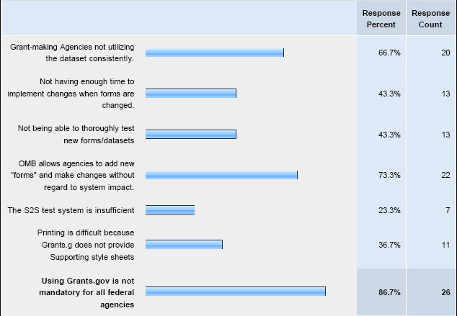

16. Please provide any additional information on your decision to use or not use S2S at your institution.

Why did institutions decide to use S2S?
- Supports faculty
- User friendliness
- Consistent and accurate information to the sponsor
- Standardization of proposal development and the approval process
- Integration with other systems
General Comments
- 2 institutions have their S2S implementation on hold until they can submit to all agencies
- Some respondents REALLY like their vendor and the system they’ve purchased
Direct Quotes
- “Our users are dearly tied to S2S and think it is the greatest thing since sliced bread or microwave popcorn.”
- “Overall, it has proven so troublesome that we equate its use to ‘nailing jello to the wall’.”

Section 5. Investment in Forms

Now we turn to what institutions have invested in Grants.gov for forms management. Some of these are one-time expenses, others are ongoing costs. Forms costs include expenses implementing and maintaining both PureEdge and Adobe Forms.

17. How has your institution invested in deploying Grants.gov forms? If you now use S2S respond to this question in the context any time you use or were using Grants.gov forms.

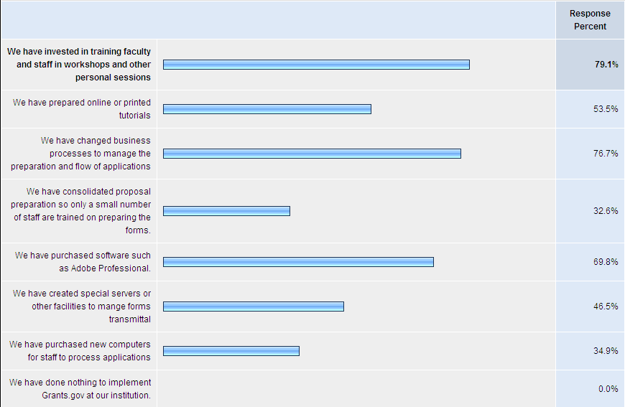

43 of the 55 respondents surveyed responded to the question on types of investments made at the institution in Grants.gov forms. As seen in the graph above, at least some of the respondents invested in each areas listed, with the top 3 investments being made in training, changing business processes, and purchasing software. Many of the respondents commented on devoting a significant amount of effort to provide training to staff and faculty on the use of the Grants.gov system. This included investing staff resources in maintaining a website, staffing a central e-mail point of contact, researching changes in the system, troubleshooting, and communicating with the Grants.gov and agency help desks.
One of the respondents stated “The biggest cash expense for us has been new computers and software. We did not add additional staff to implement Grants.gov. The biggest non-cash expense has been using our proposal staff to conduct grants.gov training sessions across campus. This training is in addition to their regular duties.”
While several respondents indicated that they changed business processes to support the grants.gov forms, one such specific example cited was “1) we had to impose a 5 business day deadline for receipt of proposals for review 2) review time for form packets is greatly increased 3) form-based submissions are more prone to errors because so much of the data is manually entered into the forms instead of being pulled from the institutional systems” Another respondent commenting “Since all the agencies use the Grants.gov forms differently (sometimes even within the same agency) a great deal more staff time is spent reading the instructions to ensure that we are placing items properly.”

18. What has been your financial investment to utilize Grants.gov forms? Investment estimates may include any of the items noted above, but only in addition to what you would normally devote to application processing.

Of the 35 responses to the “Rough estimate of cost to implement” question, only 27 are included in the analysis due to the other 8 either not knowing the cost or not being able to quantify the cost. The 27 remaining responses ranged from a low of $1K to a high of $350K. 14 respondents invested $25K or less, 4 invested $30K to $100K, 7 invested $100K to $200K, and 2 invested $200K or more.

Of the 30 responses to the “Rough estimate annual expenses” question, only 22 are included in the analysis due to the other 8 not separately accounting for annual expenses or not knowing the cost. 6 respondents indicated annual expenses from minimal to a high of $6K, 10 indicated annual expenses from $10K to $50K, 2 indicated annual expenses of $50k to $100K, and 4 indicated annual expenses of $100K or more with the highest being $250K.

Twenty-eight respondents estimated the number of FTE’s dedicated to the support of Grants.gov forms ranging from minimal or 0 to a high of 10.5. The responses did not indicate a direct correlation between cost of implementation and annual expenses to the amount of FTE’s dedicated to supporting Grants.gov forms. Eighteen of the 28 respondents reported adding one FTE or less, whereas only three added eight or more.

19. What technological solutions has your institution implemented to assist in processing Grants.gov forms?

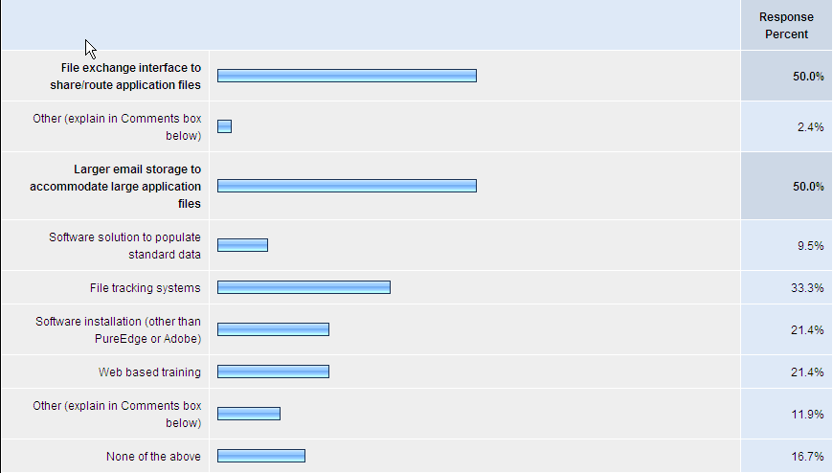

Institutions’ responses indicate a variety of technological solutions required for implementation of Grants.gov forms, with 50% of the respondents (n=42) having implemented file exchange interfaces to share or route applications and/or increasing email storage limits to accommodate large application files. Some institutions (33.3%) also developed file tracking systems. Less common responses were software installation (other than PureEdge or Adobe) (21.4%) and web-based training (21.4%). Approximately 1 in 10 respondents developed a software solution to populate standard data. Some respondents (16.7%) were able to implement Grants.gov forms without taking any action.
The comments associated with this question indicate a broad variety of technical responses to Grants.gov form implementation. One respondent noted “We have needed access to much more server space to store submitted application files.” One institution also purchased a large-scale scanner to accommodate larger applications. One institution “developed a way to attach form packets” within its existing grants management system, while another developed a “web page where faculty can upload a document”. One respondent “moved to Cayuse and then they handled” the additional technical demands.

20. What non-technical investments has your institution made to implement Grants.gov Forms?

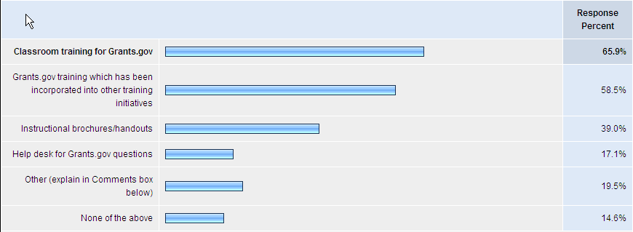

Most institutions also invested non-technical resources in order to implement Grants.gov forms, chiefly classroom training focused solely on Grants.gov (65.9%) and Grants.gov training that was folded in to other training initiatives (58.5%), with a total of 41 institutions responding to this question. Many institutions produced instructional brochures and handouts (39.0%), while others (17.1%) developed a help desk to handle all Grants.gov questions. There were clearly a variety of approaches, with 19.5% of institutions providing non-technical support for Grants.gov other than those described above. Only 14.6% of respondents did not make any non-technical investments as a result of Grants.gov forms implementation.
Comments from respondents indicate that training was a significant commitment. The training initiatives took on a variety of forms, including classroom sessions, one-on-one meetings, department trainings, web-based resources, and help desks. Many respondents indicate that the training resources were cost neutral, with an apparent opportunity cost to other efforts. One institution “put considerable effort into training departmental administrators (often one-on-one) and relying on them to train/assist faculty”. Another commented that they used “web based training using GoToMeeting and GoToWebinar applications. Previously established help desk is overwhelmed.” Beyond training, another respondent wrote “we assigned a person to be the troubleshooter so the proposal specialists are not pulled away from processing proposals to problem solve” Grants.gov form issues. Another institution has indirectly provided technical support to Grants.gov, noting that through Beta testing with a vendor of its 424 application, “we have been able to suggest improvements and locate errors in forms that have been noticed and communicated back to Grants.gov. This takes 3 to 5 days of testing and is done regularly, at least once per quarter, perhaps once every 8 weeks depending on forms released.”
21. What would you estimate is your total institutional investment for Grants.gov training using forms-based submissions on an annual basis? Include training, hardware and software, help desk support, etc.

Of the 55 respondents, 20 estimated annual costs. Of these, only 19 are included in the analysis, because one response of $1 million was considered an erroneous response. Of the remaining 19, responses range from $0 to $175K, with a slight preponderance of responses at the lower end of the scale. In the text comments, four respondents described their annual investment as “minimal” or “very small.” Four said that Grants.gov related tasks such as training users or managing submissions were performed by existing staff or otherwise incorporated into existing business practices. Three respondents said it was difficult to estimate costs, at least in part because there were no additional resources available to attend to Grants.gov. One respondent observed, “The cost of going with Grants.gov evens out or is lower than the cost of printing hard copies, copying and federal expressing.” While this may not be the most widely held sentiment, the evidence of minimal investment at the institutional level may be an indication that at least in some cases additional resources have not been or are no longer a necessity.

22. Please tell us any additional thoughts you have about your cost and investment in using Grants.gov forms.
There were 15 responses to this question, with little new information provided than what has been stated earlier. One commenter said, “Grants.gov forms do not add any value to the submission process for institutions other than to give the feds the information in the format that they require.” Another, on the other hand, made this plea, apparently asking agencies not to abandon Grants.gov, “Let's not go back to the last century.” Three respondents mentioned that inconsistency among federal agencies as to how Grants.gov forms are used is a problem. Echoing the theme of the costs of implementing Grants.gov forms being hidden in general operating costs were those who said, “The biggest cost has been in diverting staff from their day-to-day duties.” Another said, “AORs spend a great deal of time as proposal deadlines loom answering questions concerning technical issues, as well as forms content requirements.” Three said that their implementation of forms went fairly well, and that they had been able to incorporate the use of forms into their operations. One even said they had tried S2S and decided to use forms instead, “Our S2S venture was costly and did not meet our needs at the time of implementation. The form based submissions using Adobe are currently meeting our needs given our diverse portfolio given that Adobe works across platforms.” On the other hand, there is this comment from another S2S school, “If we did not have a S2S that has been so exceptional, I don't believe we could have survived the past two years and I mean that honestly. Our funding has increased approximately 30% in that time period without a commensurate increase in staff and other resources.”

Section 6. General Comments and Suggestions for Grants.gov
For the short term (12-18 months) what changes would you like to see in Adobe Forms and the submission process? Please list only the 5-6 major issues you would like fixed or improved.

In October of 2009, an additional survey was created to determine user priorities from two groups: 1.) Adobe Forms, and; 2.) System-to-Systems (S2S). The list of priorities presented in the survey to these two groups were derived from responses to this section. These responses were categorized into the two groups – Adobe Forms and System-to-System then presented in the follow-up survey for ranking. The results of that ranking follow.

Survey ranking for top 5 Adobe Forms Issues

- Option to view or print the entire application as one complete document
- Require all agencies use form fields the same way
- Allow users to enter standard institutional data from a master profile (or re-use an old application)
- Ability to work on given budget year or key person at any time without having to complete the previous budget year or key person information
- Ability to see all errors in the application when the ‘check for errors’ feature is used

Percent ranking each question

Survey ranking for System-to-System Issues

- Infrastructure
  - Grants.gov should provide style sheets for Adobe forms; otherwise every S2S institution will have to individually develop their own in order to display or print the data

- Test Environment The S2S community would like to actively participate in testing Grants.gov changes before they are moved to production. Coordinated beta testing with a subset of S2S organizations would ensure that problems are found earlier in the lifecycle and lead to increased satisfaction with the final product. Key components on the Grants.gov side:
  - Provide a stable and robust test environment that is available 24 hours a day.
  - Mirror all active opportunity packages in the UAT environment for improved testing.
  - Work with the S2S beta testing group to establish effective and timely testing procedures.

- Version Control - New forms and functional enhancements are often moved into production with little advance warning; leaving the S2S community scrambling to catch up. An organized, documented and systematic version control process would provide the S2S community adequate time to make the necessary coding changes in their own systems. Key components would include:
  - The current system status and key system performance metrics should be available automatically and in real-time to all consumers of grants.gov web services.
  - Error messages must clearly communicate the problem and not mask unrelated issues such as server congestion.
  - Status of current development and infrastructure work(including major milestones, project health status, etc) should be public; where possible, project artifacts should be available for public review and comment.

- Transparency - The dependence on S2S is growing and many institutions rely solely on S2S for their proposal submission process. As a result, the S2S community requires greater visibility into current status and the S2S technical roadmap in order to meet the needs of their institutions.
  - The current system status and key system performance metrics should be available automatically and in real-time to all consumers of grants.gov web services.
  - Error messages must clearly communicate the problem and not mask unrelated issues such as server congestion.
  - Status of current development and infrastructure work(including major milestones, project health status, etc) should be public; where possible, project artifacts should be available for public review and comment.

- The S2S community would like to activity work with Grants.gov and the federal agencies to establish standards and reduce redundancy. As partners, we are willing to review all new proposed schemas for consistency and accuracy to:
  - Ensure the use of common enumerations (e.g., state and country codes)
  - Identify structural issues (looping versus fixed nodes)
  - Use of child nodes rather than reference
  - Ensure no transformations of the XML file are performed at Grants.gov (e.g., subaward budget, Fed/non-Fed subaward budget)
  - Provide "unstitched" PDF files that will validate against the Grants.gov schema.
  - Identify misspellings, etc.

24. What have been the positive impacts of Grants.gov at your institution?
Respondents provided more than 50 comments on the positive impacts of Grants.gov for the ‘Find and Apply’ process. There were 4 major categories represented by these comments as depicted in the follow graph:
A few representative comments:
- PureEdge Viewer is gone!
- Saves shipping and copying costs. We have the final document!
- Single funnel for the application process
- Fewer errors, faster submission process, one institutional sign-off, faculty focus on science rather than inconsistent application process, status of application through entire process

25. What have been the negative impacts of Grants.gov at your institution?
Respondents also provided more than 50 comments on the negative impacts of Grants.gov for the ‘Find and Apply’ process. There were 4 major categories represented by these comments as depicted in the follow graph:

A few representative comments:
- Speed of submission after application is completed
- The Help Desk is not knowledgeable about technical issues
- Increased burden in providing technical resources, training and staff
- Inconsistent use across federal agencies
Note: Recently Grants.gov has invested in improving both system reliability and help desk support – the two elements that can be improved quickly. Anecdotal evidence is that these efforts have been at least partially successful. The FDP will provide a future follow-up survey to measure improvements.

