NEW TASK GROUP PROPOSAL FOR PRESENTATION TO THE
28th CODATA GENERAL ASSEMBLY
CODATA Task Group on Advancing Informatics for Microbiology (TG-AIM)

[NEW TASK GROUP PROPOSAL FOR PRESENTATION TO THE
28th CODATA GENERAL ASSEMBLY]

2012-1-18

NEW TASK GROUP PROPOSAL FOR PRESENTATION TO THE
28th CODATA GENERAL ASSEMBLY,
Taipei, 1-2 November 2012

Task Groups should endeavour to support CODATA’s strategic objectives and activities where appropriate, as articulated in the CODATA Strategic Plan, 2006-12. http://www.codata.org/archives/2006/CODATAstrategicPlan.pdf
The Strategic Plan is currently being updated for the 2013-18 period.
Task Groups may also wish to explore synergies with ICSU strategic priorities
(http://www.icsu.org/about-icsu/strategic-priorities).

1. Name of the Proposed Task Group
“CODATA Task Group on Advancing Informatics for Microbiology (TG-AIM)”

2. Objective(s) of the Proposed Task Group
Objectives:
Microbes play a key role in the material cycles of Earth. Microbes sustain the homeostasis of the planet and constitute the largest part of its biomass. Microbiologists have studied microbes for hundreds of years, producing new research insights and applications. Many industries—biomedical, agricultural, food, environmental and most recently, energy—have been created based on the different functions of microbes. As a result of this long history of research and industrialization, many microbes have been isolated, characterized and preserved (when possible) in culture collections, although the vast majority of them have yet to be discovered.
Recognizing the value of microbes and the importance of preserving them ex situ for the reproducibility of science and technology, the Organisation for Economic Co-operation and Development (OECD) published a report entitled, "Biological Resource Centres (BRCs) - underpinning the future of life sciences and biotechnology", in 2001. This seminal report pointed out the impacts of biodiversity, genomics and informatics to microbiology and the emerging BRCs and recommended that culture collections evolve toward higher BRC standards.
The developments in the past decade have been even greater than the report foresaw. Since 2001, the observational data of biodiversity have increased very much, sequence data have increased explosively and the capabilities and uses of information technologies have expanded greatly. Therefore, microbiology has also become a data science. BRCs also have to function as data and information repositories to serve academia, industry and the public. In the age of microbial data diversification and explosion, this proposed CODATA Task Group on Advancing Informatics for Microbiology (TG-AIM) would focus on developing an effective information environment that promotes and sustains microbial research data activities, sharing and use to help advance progress and bridge the gaps within and outside the microbiology communities.
As of early 2011, 586 culture collections in 68 countries have registered in WDCM, submitting 224 online catalogues of cultures including 1.7 million strains. A large amount of microbial resource information, however, remains unregistered and not online. Each culture collection is independently responsible for the maintenance of its own cultured microbes. At present, there is no existing uniform data and information sharing and collecting mechanism, which hinders both the management and statistics of world microbial resources and the potential users’ query and retrieval of information. Therefore, developing a digital, online resource sharing mechanism is an urgent need and a foundational premise for good information management. This should include a mechanism for improving the sharing of microbial strains and pertinent related information, the ability for users to provide feedback after the resource sharing, appropriate intellectual property rights, and other characteristics identified by the Task Group. Moreover, we plan to involve and coordinate experts within the WDCM and outside to formulate data standards. These standards should include the data acquisition process, data quality control, data specification and other requirements for meaningful data sharing. We plan to issue, on behalf of WDCM and CODATA, a global microbiological data and information sharing mechanism and interchange standards.

More specifically, the objectives of the proposed Task Group on Advancing Informatics for Microbiology are to:
- Improvement of interoperability of microbial data and information between microbial research groups and culture collections to promote the access and use of data and information.
- Help coordinate international cooperation with more than 500 microbiological culture collections from 68 countries for data and information preservation and access projects.
- Provide training and education to promote application of cutting-edge information technology (IT) for this microbial resource information system.
- Organize workshops and conferences focused on IT, data and information management, intellectual property and other relevant issues to help promote data activities in various sectors of research and applications.

3. Membership of the Proposed Task Group
(Please give institution, area of expertise, telephone, and e-mail of each member; indicate if the individual has been invited to participate and agreed to serve, or if the individual has not yet been contacted. Note also that participation by scientists from around the world as members of the Task Group and in Task Group activities is strongly encouraged. Particular attention should be given to gender balance, and representation from developing countries.)

List in Alphabetical order
Name | Area of expertise | Institution and post title | Email and Telephone
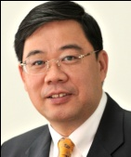  Juncai Ma  Chair | Director of Information Network Center, Director of WDCM | Institute of Microbiology, Chinese Academy of Sciences (CAS), China | 13701392988  Ma@im.ac.cn
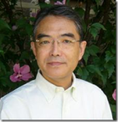  Hideaki  Sugawara  Co-Chair | Former Director of WDCM | National Institute of Genetics, Japan | hsugawar@genes.nig.ac.jp
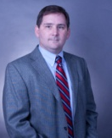  Kevin McCluskey  Co-Chair | Bioinformatics | School of Biological Sciences, University of Missouri- Kansas City, USA | mccluskeyk@umkc.edu
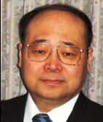  Hideharu Anazawa | Industrial biotechnology | Research & Development Department, Japan Bioindustry Association, Japan | anazawahdhr@jba.or.jp
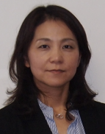  Hiroko Kawasaki | Microbiology | NBRC, National Institute of Technology and Evaluation(NTIE), Japan | kawasaki-hiroko@nite.go.jp
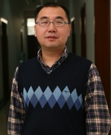  Jianhui Li | Information technology | Computer Network Information Center, Chinese Academy of Sciences, China | lijh@cnic.cn
  Ken Kurokawa | Bioinformatics | Department of Bioinformation  School and Graduate School of Bioscience and Bitechnology  Tokyo Institute of Technology, Japan | ken@bio.titech.ac.jp
  Peter Dawyndt | Database in Microbial Resources | Department of Applied Mathematics and Computer Science, Ghent University, Belgium | Peter.Dawyndt@UGent.be
  Philippe  Desmeth | Management and policy, President of WFCC | The Belgian Co-ordinated Collections of Micro-organisms (BCCM), Belgium | Philippe.Desmeth@belspo.be
  Scott Edward Baker | Application of genetic, genomic and proteomic strategies in fungal biology | Oregon State University, Corvallis, Oregon | scott.baker@pnnl.gov
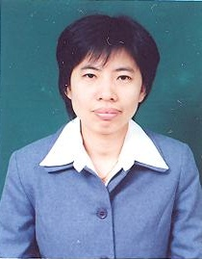  Supawadee Ingsriswang | Information system of microbial resource | BIOTEC Culture Collection, National Center for Genetic Engineering and Biotechnology, Thailand | supawadee@biotec.or.th
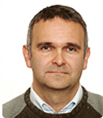  Vincent Robert | Bioinformatics | CBS Fungal Diversity center,  The Netherlands | v.robert@cbs.knaw.nl
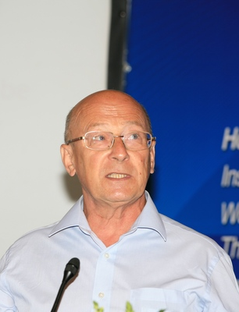  Vasilenko Alexander | Microbiology | All-Russian Collection of Microorganisms (VKM), Russia | vanvkm@gmail.com
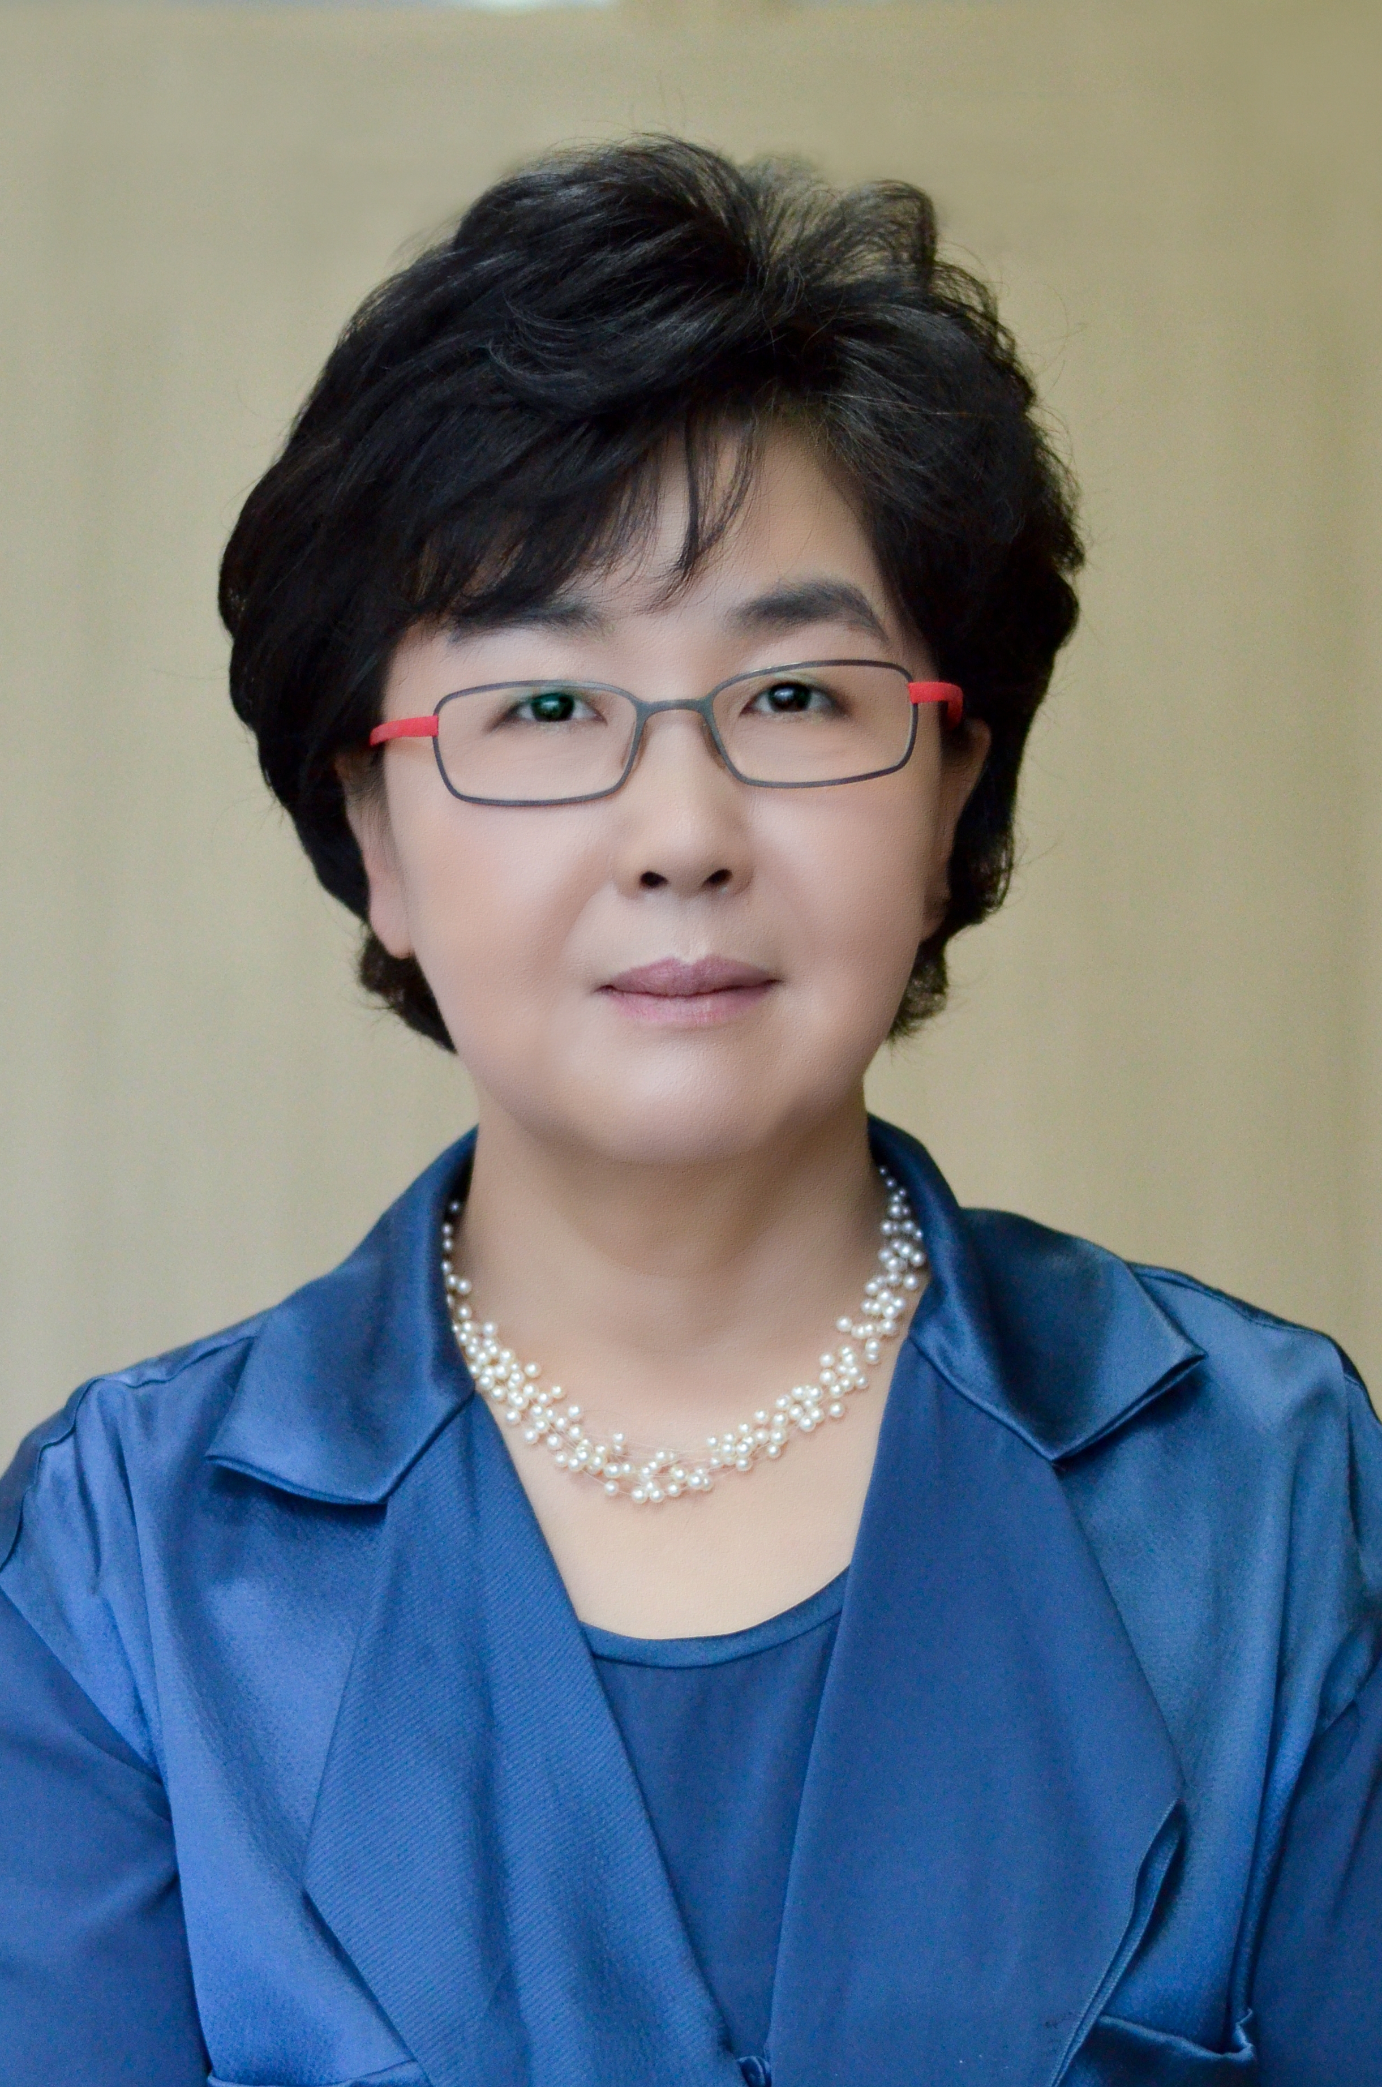  Yeonhee Lee | Microbiology | Korea National Research Resource Center (KNRRC), Korea | anrrc@knrrc.or.kr
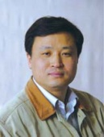  Yuguang Zhou | Microbial resource preservation and utilization | China General Microbiological Culture Collection Center, China | zhouyg@im.ac.cn
  Linhuan Wu | Bioinformatics,  Secretary of TG, | Institute of Microbiology, Chinese Academy of Sciences (CAS), China | wulh@im.ac.cn

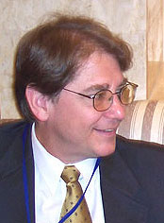
Consultant:
Paul F. Uhlir, J.D. Email: puhlir@nas.edu
Director, U.S. National Committee for CODATA and Board on Research Data and Information, National Academy of Sciences, Washington, DC

4. Please indicate whether young scientists are going to be involved in this Task Group. If so please provide details.
Young scientists are very much welcome and encouraged to work in this Task Group. Dr. Peter Dawyndt, aged under 40, is the chief scientist of StrainInfo and will participate in TG-AIM. StrainInfo.net operates through an Integrated Strain Database, a curated central repository that provides a global view on the synonymous labels assigned to biological specimen during their lifetime. Dr. Supawadee Ingsriswang, aged under 40, who is the chief manager of microbial resource information system in BIOTEC Culture Collection, will participate in TG-AIM to contribute her experience to microbial resource data preservation. Initially, Ms. Linhuan Wu, aged under 30, who is now working in World Data Center of Microorganisms for constructing global information management system will join in this Task Group, and she will also serve the group’s administrative needs.

5. Deliverables and activities planned to be completed by the 2014 General Assembly
- Articles in the CODATA Data Science Journal http://www.codata.org/dsj or other refereed Journals
Articles on the WDCM Data Standards for Microbial Resources
According to the Task Group’s major activities, the TG members will publish papers concerning management software, data standards and policies related to data and information on microbial strains.
- Data products, Web resources, tools, or other digital outputs
(1)WDCM Management System of Microbial Strains
The TG-AIM will formulate a set of sharing standards of microbial resources data and information in line with the OECD guidelines on microbial resources, according to which a microbial resources data and information management system will be established. We will standardize the catalogues of major culture collections, providing them with a unified retrieval output. We will develop the prototype system of a world microbial strain catalogue and promote agreement on the data interface, which will enable seamless links among all the platforms.
(2) Application of cloud computing and cloud storage technologies in microbial resource data and information preservation and services.
We plan to construct a central repository of microbial resource data and information, and to provide unique services to the research community, cloud computing and cloud storage technologies to provide promising solutions to integrate separated digital resources. The TG-AIM will focus on applying cutting-edge technologies in the microbial resource information system to promote better data and information sharing and utilization.

- Other products or accomplishments
(1) We will establish the global microbial data and information sharing mechanism through the international coordination of experts in accordance with OECD data standards on microbial data resources.
(2) Reference strains have been defined for the safety and quality assurances of microbial experiments and application by countries and also international bodies. Each set of reference strains is not necessarily compatible one another. In this regards, we will compile an international reference strain catalogue which records the detailed information of type strains according to ISO standards kept in each culture collection, as well as their roles in environment monitoring, food testing, and so on.
(3) We will establish a scientific community system platform serving worldwide culture collections and researchers who focus on microbial resources. The platform will integrate such functions as members’ communication, literature access citation analysis of research papers services and group discussion capabilities. A global digital collaborative platform will enhance the communication and cooperation of culture collection staff and researchers, and accelerate the globalization of services.
(4) We plan to establish a working group of experts on world microbial resource database development with a WFCC executive board, organize periodic seminars and formulate a long-term strategy and planning for the development of world microbiological data and information resources.
(5) Finally, the CODATA TG-AIM would cooperate with a major WDS center (WDC-M) and organizations (WFCC and WDS), all of which are part of ICSU and a strategic goal of ICSU, CODATA, and WDS. It also would bring a whole research community (microbiology) into the CODATA ambit, so we believe this would be a major positive development internationally for CODATA and the other organizations.

6. Organization and schedule of task group activities (e.g., planned subgroups, meetings, teleconferences, responsibilities of key participants or organizations, key milestones)
From the beginning of 2013, we expect every year:
1、an annual meeting and task group (with sub-groups as appropriate);
2、at least one training course on the microbial resource information system; and
3、publish an annual report of world microbial resource information system advances (see also the list of TG-AIM objectives above for the work focus of the Task Group).
Every half year: a video conference of TG-AIM members.

7. Financial support from sources other than CODATA International (indicate if committed or expected)
- Grants and Contracts
(1). Bureau of Life Sciences and Biotechnology, CAS
Research on microbial resources and their data is one of the important fields supported by the Bureau of Life Sciences and Biotechnology, Chinese Academy of Sciences CAS (BLSB-CAS). In the future, BLSB-CAS will sponsor research programs to keep backing up support the WDCM, as well as the research on microbial resource data and information, and their application.
(2). CAS Informatization Program
The CAS Informatization Program has offered long-term support to the microbial resources database, the data service system, the collaborative environment and related e-Science applications. The Task Group will apply for financial support from the CAS Informatization Program to facilitate the development of the data and information management system and collaborative environment.
(3). The Ministry of Science and Technology of the People’s Republic of China
The TG-AIM expects to get financial support from MOST through the projects of the National High-Technology Research and Development Program (863 Program) and the Key Projects of the National Science and Technology Pillar Program.
(4). Research agencies in other countries
Grants will be sought from the research supporting agencies in other countries represented by the TG-AIM.

- In kind support

8. Other organizations or programs sponsoring or participating in the Task Group and their expected role(s)
The Asian BRC Network (ABRCN) of the Asian Consortium will support the Task Group through the Conservation and Sustainable Use of Microbial Resources (ACM). The ABRCN of ACM is responsible for analyzing the needs for, and seeking the way to establish, a biological resource center network in Asia. The ABRCN is constructing the network of biological resources for Asian countries, whose mission is to facilitate data and information sharing, communication and usage among those counties. The network now involves the China General Microbiological Culture Collection Center (CGMCC), the National Institute of Technology and Evaluation (NITE) Biological Resource Center (NBRC), the Korean Collection for Type Cultures (KCTC) and the BIOTEC Culture Collection (BCC) in Thailand.
Research Network for Applied Microbiology (RNAM) is a research network organised by institutes of Chinese Academy of Sciences whose major research field focus on microbiology. The aim of this network is to promote the maintenance, development and usage of microbial resources. Involving most of CAS research groups focusing on the development and utilization of microbial resources, RNAM will provide the TG with data and information back-up and expert consultation.
Additional active involvement will be sought from the aforementioned WFCC, the European Culture Collection Organization, the U.S. Federation of Culture Collections and similar groups in other countries and regions.

9. Expected consequences/impact of the Task Group activities. Please explain how the activities will contribute to the specific aspects of CODATA’s mission, initiatives/objectives
(1). Best practices and data standards for microbial resource data and information will be established, which are expected to promote data and information sharing between culture collections and different data holders based on the same data exchange standards. The output of the TG will be essential to international and national initiatives.
(2). A worldwide microbial resource information team, organized by the TG-AIM, will conduct training courses in some culture collections and microbial resource groups with the goal of promoting application of cutting-edge IT and information management practices in the microbial resource information system.
(3). The TG-AIM will work with the WFCC, a cooperative network of almost 600 culture collections and research units around the world, to design and implement a digitally networked information environment for the preservation and exploration of microbes.

10. Suggested referees (three). Do not include any current Executive Committee members. Please include the institution, relevant area of expertise, phone number and e-mail information of each referee.
Name | Area of expertise | Institution and post title | Email and Telephone
Toru Okuda | Mycology | Mycology & Metabolic Diversity Research Center  Tamagawa University (Japan) President of the Mycological Society of Japan | torula@lab.tamagawa.ac.jp  (81 42) 739 8669
Rita R. Colwell | Microbiology | University of Maryland (US) and  ex-Director of the National Science Foundation, US | rcolwell@umiacs.umd.edu  (1 301) 405.9550
Lindsay Sly | Microbiology | University of Queensland (Australia),ex-President of World Federation for Culture Collections | l.sly@uq.edu.au  (61 7) 3365 2396

11 Other information or comments
As is known, CAS always attaches great importance to enhancing its research capacity and influence via international exchange and cooperation. By implementing programs such as the Visiting Professorship for Senior Foreign Scientists and the Fellowship for Young Foreign Scientists, CAS has set up an international exchange and cooperative system for scientists. Via these mechanisms, IMCAS can invite foreign experts to China, which will be of great help to the implementation of the proposed Task Group on Advancing Informatics for Microbiology.
The IMCAS has hosted many international conferences, including series sessions of Asian Consortium for the Conservation and Sustainable Use of Microbial Resources, Conference of Systematic Mycology and Lichenology, International Workshop on Extremophiles, Thermophiles 2009, Halophiles 2010, etc., promoting academic exchange and information sharing in relevant fields.
The Information Network Center (INC) of IMCAS is in charge of the Chinese national nodes of the Integrated Data Center of Information System for CAS Biology Specimen Museum and the Microbiology Sub-center of Chinese Biodiversity Information Center, among others. INC has already established a series of microbiological resource databases and the fungi digital specimen museum. It also has successfully developed the China Bio-Grid and the Avian Flu Information Network, on which the accessible information amounts to over 1TB, making it the largest gateway website in the field of microbiology.
INC has been equipped with a video conferencing system, based on both POLYCOM and PC POLYCOM. These systems provide good supports for conferencing multiple participants at domestic and foreign sites, and supports the real-time sharing of documents for participants and instant conversations. It is very convenient for participants to communicate with each other via this desktop conferencing system based on a laptop at any time and in any location. INC has successfully held a series of video conferences with foreign institutes via this system. Members of the TG-AIM will be able to save time and travel expenses to a great extent by using this video conferencing system.

Address:

Signed: Date:

PLEASE SEND SUBMISSIONS (PREFERABLY BY E-MAIL)
BY 31 January 2012 TO: Dr. Robert S. Chen, Secretary General, CODATA Secretariat,
5 Auguste Vacquerie 75016 Paris, France E-mail: codata@dial.oleane.com

