***White Paper Input to the National Academy of Science Fusion Study (June 25, 2017)***

**A New Tandem Mirror Concept with High Fusion Power Gain**

**T.C. Simonen1 and R.W. Moir2**

**1** [**simonen42@yahoo.com**](mailto:simonen42@yahoo.com)**, Berkeley, CA 2 Vallecitos Molten Salt Research, ralphralphmoir.com, Livermore, CA**

***INTRODUCTION*** This white paper describes an opportunity to advance magnetic fusion as an energy source. Today the ITER tokamak is a very well suited platform to explore burning plasma physics and fusion technology. The US Fusion program should fully participation in ITER as well as vigorously pursue concept improvement. As an example, the tandem mirror described here utilizes the simple magnet geometry illustrated in Fig. 1 to facilitate device construction and maintenance [1]. High field superconducting coils minimize End Plug size and cost. The End Plugs are powered by Neutral Beam Injection (NBI) and Electron Cyclotron Heating (ECH) to establish positive plasma potentials that confine an ignited Central Cell plasma. The concept is based on experimental results, new physics understanding as well as incorporates advances in super conducting magnet, ECH gyrotron and NBI technologies. Operating at 100 keV range ion temperatures either DT or Catalyzed DD fuel cycle designs provide high fusion power gain, Q=10-20. Detailed power flow calculations are given in Ref. 1.

***MIRROR BACKGROUND*** The earliest mirror confinement experiments consisted of a mirror cell with two axisymmetric (circular) coils. Such a configuration was found to be MHD unstable leading to the adaption of non-axisymmetric coils (Ioffe bars) to provide a minimum-B magnetic well that confined plasma with average beta up to 70%. However, system studies indicated that coulomb scattering into the mirror loss cone limited the fusion power gain to Q=1. This motivated the tandem mirror concept with high density End Plugs to establish positive potentials that confined Central Cell ions. Magnet field limitations restricted the fusion power gain Q<5. Furthermore non-axisymmetric magnetic geometry facilitated neoclassical radial transport. As various End Plug configurations were being investigated in the 1980s US fusion funding was cut and all US mirror research was terminated. Fortunately during the following three decades seminal experiments as well as theory work elsewhere continued most notably at the Gas Dynamic Trap (GDT) mirror facility in Novosbirsk Russia [2]. The GDT device retains MHD stability with beta up to 60% with circular magnets, average ion energies of 10 keV, densities of 1020 m-3 and, at lower densities with ECH, electron temperatures of 1 keV (a long time mirror milestone). These remarkable achievements sparked renewed interest in further exploring the mirror concept. Studies indicated that with modest GDT parameter increases one could envision stepwise applications of mirror neutron sources capable of; producing medical isotopes, testing fusion materials, producing fission fuel, burning nuclear waste, and producing hybrid fusion-fission electrical power.

***A HIGH FUSION GAIN TANDEM MIRROR*** Several game changing results [4] now provide a new outlook of mirror systems as a power source. It was predicted [3] and demonstrated that MHD stability could be achieved in axisymmetric magnet systems by several means. Foremost are GDT experiments which demonstrated betas up to 60%, by radial sheared plasma flow (akin to the tokamak H-mode) and plasma outflow. GDT also demonstrated that expansion of the end tank plasma to a magnetic field ratio (end wall to End Plug) less than the square root of the ratio of electron to ion mass isolates the confined plasma electrons from cooling on the end walls. Theory predicts, and experiments indicate, that the virulent Drift-Cyclotron-Loss-Cone (DCLC) mode which leads to the loss of plug ions is stabilized when the End Plug radius increases to 30-50 ion gyro radii. Such considerations as well as technology constraints are incorporated in the high gain tandem mirror designs indicated in Table 1. Although we have considered many issues associated with this concept further study and experiments are needed. These include physics of End Plug hot electrons, trapped particle modes, plasma startup, center cell radial transport and others [1].

This concept enables new technology features. Liquid first wall and blankets are permitted by the axisymmetric geometry to facilitate D-T operation by mitigating neutron radiation damage. The edge plasma shields the hot plasma from liquid wall evaporation. Open-ended field lines facilitate direct energy conversion of leakage plasma thus favoring advanced fuels such as D-He3 and Cat-D. Ultra-high field super conductors with their high temperature operation using liquid hydrogen (20 K) improve confinement. The field strength is not limited by critical current but rather by stress handling (think diamond anvil technology).

***SUMMARY*** This white paper describes a new way to obtain high fusion power gain in a tandem mirror without the complications of minimum-B magnets or thermal barriers. High power End Plug ECH creates potential barriers to aid confinement of central cell ions. Using technology existing or under development we illustrate a Q=10 system burning DT fuel would produce 950 MW in a 215 m long x 4 m radius 1.2 Tesla central cell. With further development of higher field magnets and higher frequency gyrotrons Q=15 systems using Catalyzed DD fuel are described in Table 1. Development and analysis of this concept requires further work by theorists and experimentalists in universities and laboratories as well as international collaboration.

***ACKNOWLEDGEMENTS*** It is a pleasure to acknowledge early as well as recent contributions of colleagues at the Budker Institute of Nuclear Physics, CompX, Kurchatov Institute, LBNL, LLNL, MIT, ORNL, TRW, U. Maryland, U. Texas, U. Wisconsin, U. Tskuba and others.

***REFERENCES***

1. T.K. Fowler, R.W. Moir and T.C. Simonen, Nuclear Fusion, **57** (2017) 056014
2. A.A. Ivanov and V.V. Prikhodko, Plasma Phys. Contro. Fusion **55**, 063001 (2013)
3. D.D. Ryutov, Phys. Plasmas **18**, 092301 (2011)
4. T.C. Simonen, J. Fusion Energy **35**, 63 (2016)

 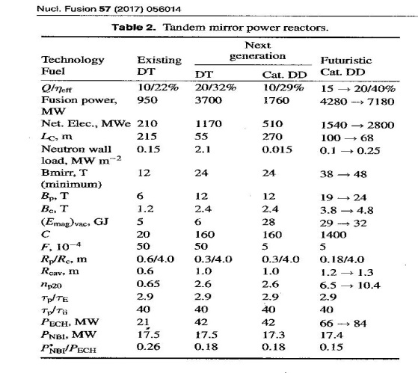

**Figure 1. Magnet and potential profile** **Table 1. Example parameters from Ref. 1**