Federal Demonstration Partnership
Redefining the Government University Research Partnership

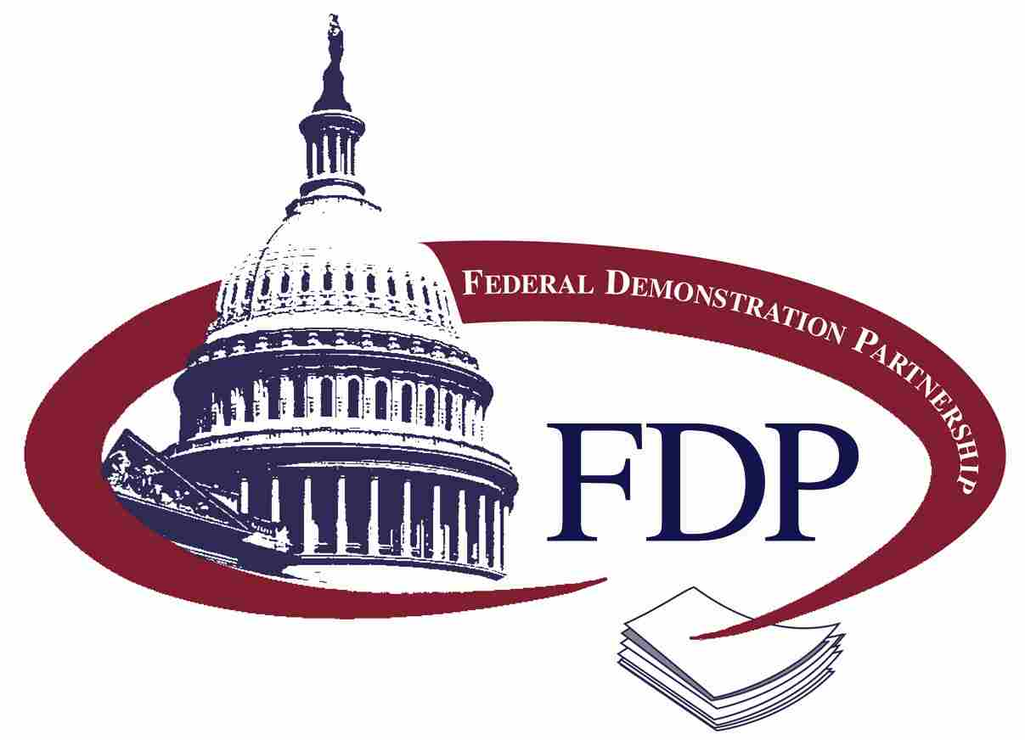

Title of the Report

Prepared by the Federal Demonstration Partnership (add committee name)

For more information about the FDP, please visit our website at http://www.thefdp.org
500 Fifth Street, NW, Washington DC 20001
Email: fdp@nas.edu
(202)334-3994

