The Impact of Data Management Mandates

Board on Research Data and Information
Policy and Global Affairs Division
National Research Council

SUMMARY
The Board on Research Data and Information proposes to undertake a consensus study to review the impact of federal data access and management mandates on research grantees, to judge whether they are working most effectively, how ambiguities might be resolved, and what changes might be suggested.
The study would be performed according to the following statement of task:
1. Assess the community experience with data availability and management requirements. Analyze the initial evidence of the benefits of more open data, and how much of a burden the requirement is placing upon research projects.
2. Describe the different choices facing each discipline in terms of confidentiality, embargoes, retention, and curation.
3. Provide conclusions and recommendations to the sponsor(s) regarding their data management mandates to grantees, indicating what aspects of those mandates are working well and which ones may need to be adjusted further.
The study would begin in the winter of 2013 and end in the summer 2014, with the publication of the committee’s report. [Note: at this point there will be about two + years of experience with the NSF data management plans, and more with the NIH requirement, so we would expect to see real estimates of both the burden and the benefits.]

BACKGROUND
Recently, the National Science Foundation imposed a requirement that all research proposals must contain a data management plan, addressing what would become of the data arising from research funded by the NSF. The National Institutes of Health instituted a similar requirement on its grantees (for grants over $500,000) in 2005. Many questions remain unanswered, including who should or can store the data, how much metadata or curation is required, how long the data must be retained, how much of a delay is tolerable before the data are made available, what needs to be done about confidentiality and privacy, and what kinds of requirements or costs can be imposed by the researchers in delivering the data to others. Different disciplines and research institutions are coming to different conclusions about all of these issues, based partly on the needs of their specific science, partly on historical practice, and other factors.
The key problem to be addressed is how much difficulty proposal designers are facing in complying with the requirement. For example, in one (unpublished) experiment conducted at Rutgers University, students assigned the task of writing a practice data management plan had widely varying ideas about the detail of metadata description that should be required, the need for an economic sustainability model (and specific proposals for funding), the potential location of the data repository, and the need for peer review or other quality assessment.
Researchers today have many concerns about data management; some of these worries, of course, arise from inexperience, but they are nevertheless common. Below is a chart from a study at the University of Oregon indicating the main data management issues identified by that university’s researchers [reference?]:
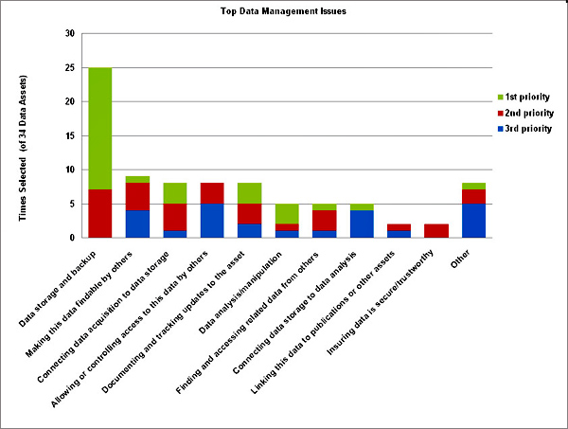
Some scientific disciplines (such as protein chemistry and climatology) rely very heavily on shared data, while others such as high energy physics do not. Although it has proven difficult to quantify the rate of progress in research, there are certainly anecdotes supporting the benefits of open data (for example, in a recently publicized study of predicting the onset of Alzheimer’s disease).
Based on various fact-finding efforts described below, the committee will assess the data management policy(s) and make recommendations for future proposal cycles.

PRELIMINARY PLAN OF ACTION
[Add list of the study committee’s composition and balance attributes.]
The study committee will interview a cross-section of proposal writers in different disciplines covering all directorates at NSF and at other sponsoring organizations, as well as the program officers at the agency(s) who are responsible for reviewing the proposals and the funded research project results. The grantees will be asked about their experiences in creating the plan and the budget estimate for complying with it. They will also be asked about what benefits and challenges they have encountered with the enhanced data sharing. The study committee may identify other issues that need to be explored.
These interviews will be supplemented with a review and analysis of the relevant literature, including the experiences of scientists and administrators from other countries, since researchers in Australia and Finland, among other places, have been subject to data access mandates for some years.
The committee also will organize a two-day workshop to get additional information from the research community and to explore in depth some of the principal issues that are raised in the statement of task and others that have been identified during the course of the study.
The committee will meet once to organize the study and the workshops meet after the workshop, and then meet two more times to write the report and agree on the conclusions and recommendations.

References

“Data Services for the Sciences: A Needs Assessment,” Brian Westra, Ariadne, issue 64, July 2010.
National Research Council
Bits of Power: Issues in Global Access to Scientific Data (1997).
Ensuring the Integrity, Availability, and Stewardship of Research Data in the Digital Age (2009).
[add other relevant NRC and external references]

