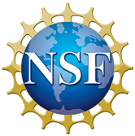
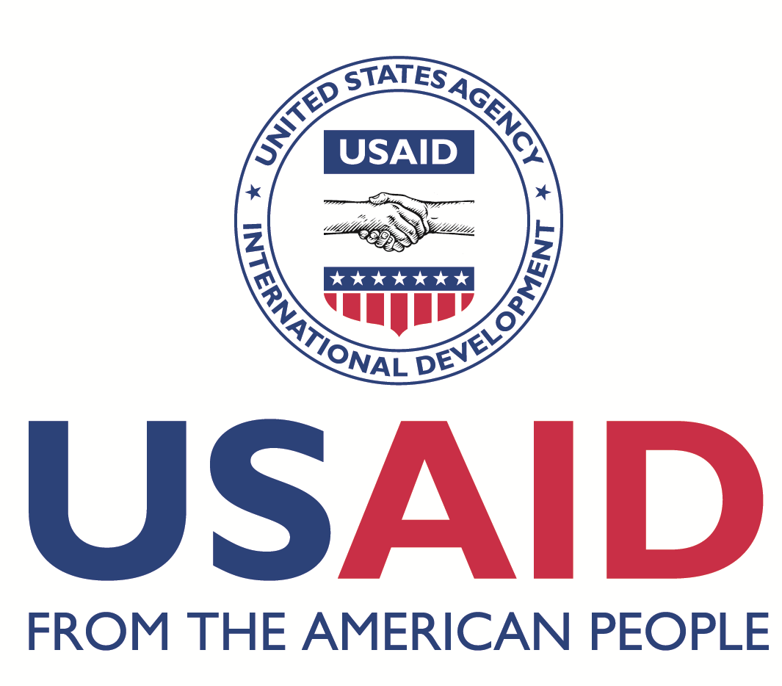
Partnerships for Enhanced
Engagement in Research
(PEER) Science

Agenda
PEER Science Participants’ Conference 2013, Bangkok, Thailand
(unless specified, all events will be held at the USAID Asia Regional Training Center,
31st Floor, Athénée Tower, 63 Wireless Road)

Monday, September 30

7:00 p.m. Welcome Reception and Registration; distribution of badges and welcome packets
Location: Star 29 Room, Plaza Athénée Hotel

Tuesday, October 1: “Big Picture, Getting to Know Each Other”

8:00 a.m. Registration (latecomers)

9:00 a.m. Welcome/Introductions

9:20 a.m. PEER Science Program Overview: History, Purpose, Significance, and Future (Water, Data, Open)

9:40 a.m. Logistics: Safety Video, Objectives, Video Recordings, and “Parking Lot” (Board to Post Questions, Comments, etc.)

10:00 a.m. “Flash Talk” Training and Breakout groups: Explaining Your Research in Under 3 Minutes

10:45 a.m. Break/refreshments

11:00 a.m. Flash Talks

12:00 p.m. LUNCH
Location: London Room II and III, Plaza Athénée Hotel

1:30 p.m. Flash Talks

2:30 p.m. Utilizing Your U.S. Partnership
Dr. Kent Carpenter, Old Dominion University
Dr. Christa Hasenkopf, University of Colorado
Dr. Olaf Jensen, Rutgers University

3:30 p.m. Break/refreshments
(if possible, tomorrow morning’s poster presenters should
hang their posters as directed by training center staff)

4:00 p.m. Building International Bridges and Taking on Global Challenges through Science: Lessons Learned from PEER Science Cycle 1
Dr. Maria Carmen Ablan Lagman, De La Salle University
Dr. Nguyen Thi Kim Oanh, Asian Institute of Technology
Dr. Lareef Zubair, Foundation for Environment, Climate, and Technology

5:15 p.m. Last chance for tomorrow morning’s poster presenters to hang their posters as directed by training center staff

Wednesday, October 2: “Successfully Managing Your PEER Science Grant”

9:00 a.m. Poster Session
PIs from first group of flash talks yesterday

10:30 p.m. Break/refreshments

10:45 a.m. Announcements and Evaluation Responses

11:00 a.m. Writing an Independent Research Grant
Dr. Geraldine Richmond, University of Oregon

12:00 p.m. LUNCH
Location: The Reflexions Room, Plaza Athénée Hotel

1:30 p.m. Flash Talks

2:30 p.m. USAID’s Regional Development Goals: How Your Research Can Address Problems in Your Country and How to Connect with USAID Missions
Dr. Teffera Betru, USAID/Cambodia
Dr. Sheila Desai, USAID/India
Dr. Teresa Leonardo, USAID Regional Development Mission for Asia

3:30 p.m. Break/refreshments
(if possible, tomorrow morning’s poster presenters should
hang their posters as directed by training center staff)

4:00 p.m. Flash Talks

5:00 p.m. Last chance for tomorrow morning’s poster presenters to hang their posters as directed by training center staff

5:30 p.m. Buses depart for Dinner Cruise on the Grand Chaophraya
Group assembly in Plaza Athénée hotel lobby

Thursday, October 3: “Having Development Impact with your Research”

9:00 a.m. Poster Session
PIs from second group of flash talks yesterday

10:30 a.m. Break/refreshments

10:45 a.m. Announcements and Evaluation Responses

11:00 a.m. Mentoring, Including Presentation on USAID’s Global Research & Innovation Fellowship Network (GRIFN)
Dr. Rachel Parker, USAID Office of Science and Technology
Dr. Geraldine Richmond, University of Oregon

12:00 p.m. LUNCH
Location: The Reflexions Room, Plaza Athénée Hotel

1:30 p.m. Importance of Reaching Outside the Scientific Community: Making Your Voice Heard to the Public and to Policy Makers
Mr. Nalaka Gunawardene, TVE Asia Pacific
Ms. Ramona Angelescu Naqvi, Global Development Network
Dr. Bernard Slippers, University of Pretoria

3:00 p.m. Break/refreshments

3:30 p.m. Getting Your Research Published
Dr. Noelle Gracy, Elsevier BV
Mr. Ravi Murugesan, AuthorAID
Dr. Richard Primack, Boston University

4:30 p.m. Communicating with Your Grant Manager and Financial and Administrative Management of Your Grant
Dr. Dalal Najib, National Academy of Sciences
Ms. Kelly Robbins, National Academy of Sciences

Friday, October 4: “Funding Beyond PEER”

9:00 a.m. Identifying and Approaching Future Funders
Dr. Simon Grimley, European Commission
Mr. Luc Le Calvez, CNRS (French National Center for Scientific Research)
Mr. Hideki Mizuma, Japan Science & Technology Agency
Dr. Mary Thomas, Bill & Melinda Gates Foundation
Mr. Masahito Yano, Japan Science & Technology Agency

10:30 a.m. Break/refreshments

11:00 a.m. Opportunity for Last-Chance Questions and Answers, Future Directions, Final Words, and Advice for the Future; Group Photo and Presentation of Certificates

12:00 p.m. End of Meeting

