**Placing a Bet**

**A New Therapy for Parkinson’s Disease**

***An Educational Module***

**Prepared by**

**Kevin W. Sharer**

**Senior Lecturer**

**Harvard Business School**

**Harvard University**

**For**

**Committee on Preparing the Next Generation of Policy Makers for Science-Based Decisions**

**Committee on Science, Technology, and Law**



**June 2016**

The author would like to thank Zarah Sikora, Faculty Assistant, Harvard Business School for her assistance with the preparation of this module.

**Contents**

Placing a Bet: A New Therapy for Parkinson’s Disease 1

A Decision for Biotex 1

Parkinson’s Disease 2

GDNF and its Relationship to Parkinson’s Disease 2

GDNF Development History and Current Status 3

Human and Non-Primate Safety Studies of GDNF 4

GDNF Development Post Amgen 5

Drug Development and Commercialization Process 7

Exhibits 8

**Exhibit 1**Biotex Financial Summary 9

**Exhibit 2**GDNF 12

**Exhibit 3**Summary of Amgen’s Randomized, Double-Blind Trial of GDNF in Parkinson’s Disease 13

**Exhibit 4**Background Information on GDNF: A Timeline 14

**Exhibit 5**GDNF Administration Diagram 15

**Exhibit 6**GDNF Treatment Model 16

**Exhibit 7**The Biopharmaceutical Research and Development Process 17

Instructors’ Guide for A New Therapy for Parkinson’s Disease 18

Introduction 19

Synopsis 19

Purpose 19

GDNF as a Therapy 20

Considering the New Injection System 21

Structuring a Bid 21

Building the Business Case 22

Discussion Questions 23

Context 23

Prospects for GDNF 23

Assessing the Injection System 23

Structuring the Bid 23

Placing a Bet: A New Therapy for Parkinson’s Disease

A Decision for Biotex

Peter Dillon, the chief executive officer of the biopharma company Biotex, sat in his conference room in October at the conclusion of the annual budget and long-range planning meeting. Biotex was a multibillion dollar in revenue, research-based biopharma company that was fully integrated from basic biological discovery to worldwide sales and marketing. The company had five large revenue drugs on the market and a number of smaller products addressing a range of therapeutic areas, including cancer, autoimmune diseases, and kidney failure. Profitability was strong with operating margins in the 35% range, and the company invested heavily in research and discovery by allocating close to 18% of sales to this vital function (see Exhibit 1, a company financial summary). However, recently the company and industry in general had come under severe criticism for investing too much in research and development with, according to critics, little to show for their efforts. It often took 10 to 15 years to develop a product, so dry spells happened. While Peter felt good about the drug development pipeline, he knew biology and medicine were uncertain endeavors, and disappointments happened often, either from clinical trial failures or regulatory reversals. It was a very risky, high-stakes business with full product development costing upwards of $2 billion over the lifetime of a single product. Biotex prided itself on being a patient-focused, science-based company and pushing the boundaries of science and changing the practice of medicine by developing effective and safe therapies for grievous illness. Peter was a lawyer by training with significant industry experience including stints in marketing, finance, and business development. While he was science educated at the level of the *New York Times* science section, he was a layperson when it came to the exquisite complexity of human biology. A key decision facing the company was whether to license a mid-development-stage molecule called GDNF (glial cell-derived neurotrophic factor) and potentially commit hundreds of millions of dollars to advancing its development as a possible cure or near cure for Parkinson’s disease.

Biotex had no neuro-active molecules on the market and little institutional expertise in the area. Moreover, it is notoriously difficult to develop drugs that target the nervous system. Taking on GDNF would crowd out some other early-stage work, require hiring new and difficult-to-find talent, scaling up complex and expensive manufacturing, and interacting with the notoriously tough Food and Drug Administration (FDA) neuro-product regulatory branch. Jim Swatz, head of research and development, had just left Peter’s office having said that he thought they should proceed, but it was no “slam dunk.” Peter had told Jim that he should aim high and take risks, and Parkinson’s was an aim-high target. Other key staff members were cautious, and the board offered little useful counsel on the matter. Besides the medical and regulatory risk, Peter had to consider if Biotex could achieve a good financial return with the investment. He reviewed the bidding and decided to sleep on the decision, but knew he had to decide soon. There were other bidders, and Goldman Sachs was conducting the process. No more data was forthcoming. The ball was fully in his court.

Parkinson’s Disease

Parkinson’s disease is a progressive movement disorder that limits the patient’s ability to perform everyday tasks in the early disease stages and, over a number of years, leaves the patient bedridden. The disease is often fatal and receiving the diagnosis sentences the patient to a certain, inexorable decline. In the early stages, the disease manifests itself in barely noticeable tremors, but over the years, it becomes more and more debilitating. Parkinson’s is rightly feared as a scourge and is often grouped with Alzheimer’s disease and amyotrophic lateral sclerosis (ALS, or Lou Gehrig’s disease) as the three most devastating and widely presented neurodegenerative disorders. The underlying biology and course of the disease is not totally understood, but it is clear the disease renders neurons in the substantia nigra movement center of the brain inoperative as they wither and die. The exact route of the degeneration is not fully known, but any therapy that could improve neuronal systemic function would be promising. No curative therapies are available, with some deep-implant electrotherapies and other moderate, at best, symptom treatments constituting the best medicine has to offer. The need is great, with an estimated 1% of people over 50 years affected, and with attendant large direct and indirect costs to society that have been estimated conservatively at $25 billion per year in the United States alone. Today, more than 6 million people suffer from the disease. While progression from moderate to severe disease state varies, several years are common. From severe-stage onset to death can take many years, making a medicine that meaningfully delays or even halts progression a tremendous benefit to patients and society.

GDNF and its Relationship to Parkinson’s Disease

Glial cell-derived neurotropic factor is a large molecule consisting of 135 amino acids that are connected in a specific sequence and are folded into a precise spatial configuration (see Exhibit 2). For the molecule to safely and effectively perform its intended biological function, the sequence and spatial configuration must be exact. This sequence and configuration are achieved naturally in the body, and must, through highly demanding, technologically complex and heavily regulated manufacturing, be replicated outside the body using biotechnology methods for which Biotex was well experienced. GDNF is a molecular growth factor which acts on neurons in the brain in a variety of ways that can counteract the degenerative effects of Parkinson’s disease. The human brain is a wonder of nature in its complexity, capacity, and range of function, and is also at best partially understood in each of these areas. However, at its elemental level it consists of billions of interconnected neurons, which are the functional building blocks of the system. Neurons respond to electrical stimuli and connect to each other via axons, which are nerve fibers that connect neurons to each other and also connect to other cells, including muscle and gland cells at junctions called synapses. Dopamine is a chemical that plays a number of roles in the brain, including reward systems and motor control. It is produced by special neurons and is critical to the functioning of the neuronal circuits that transmit motor-control signals. Parkinson’s disease degrades and ultimately destroys these dopamine-producing neurons and then degenerates and ultimately destroys much of the movement-control circuitry in the brain. The effect of Parkinson's disease in its most elemental description degrades the neurons that produce dopamine, thus degrading movement control. Ultimately, this progression can cause cell death and more than 100,000 patients die annually. The disease usually progresses over many years, with the ultimate cause of patient death not completely understood, but as more autonomic functions like swallowing are affected, serious mortality risk factors develop.

GDNF acts to restore damaged neurons to dopamine-producing status as well as sprout new connections via axon and synapse regeneration. Moreover, GDNF resensitizes damaged neurons to more normal dopamine sensitivity, thus improving the motor control function. The underlying biological cause of Parkinson’s disease and its cell destruction is not understood, but there is evidence that GDNF delivered to the right neurons in the right doses over the life of the patient will greatly retard disease progression, and, in so doing, both increase life expectancy meaningfully and also deliver years of much-improved quality of life. These effects have been hinted at in human trials, but not proven. Current therapies are early-stage treatments that relieve symptoms through dopamine addition, but ultimately fail as the neurons decay. There are no potentially disease-modifying agents in human trials except GDNF. There is much research under way now, including stem cells and gene therapy, but they are years away, if ever, from being proven. Should GDNF be proven in clinical trials, it likely would in effect be the only disease-modifying agent available for years to come.

GDNF Development History and Current Status

GDNF was first cloned by Dr. Frank Collins and other researchers at the biotechnology company Synergen in the 1980’s. Synergen conducted animal experiments that involved inducing Parkinson’s symptoms chemically in a primate’s brain. GDNF was delivered to one hemisphere of the damaged brain. The result was dramatic in the comparison of the GDNF-treated hemisphere and its associated side of the body to the untreated side. Primate models are the most closely related to the human brain, and this result caused great interest. Amgen, the largest biotechnology company, bought Synergen in 1994 largely to develop GDNF in humans for Parkinson’s disease. Dr. Collins and his team were excited to have the depth of resources and skills of Amgen to help. Other researchers outside Amgen were conducting a variety of rodent and primate trials that continued to show promise.

Dr. Steven Gill of Frenchay Hospital in Bristol, United Kingdom, implanted catheters in the brains and pumps in the abdominal walls of five patients with moderate Parkinson’s disease to deliver GDNF continuously into specific areas of the brain at a precise rate of infusion. Within 2 months of the start of the trial, patients showed improvement. As time went on, the improvement became dramatic. Brain scans showed progress even as dosage was reduced. Dramatic as the results were, the trials were open label—each patient knew they were receiving therapy. It was well known that patients knowingly receiving therapy that they believe will be efficacious will actually, for a time, improve solely due to this belief, or placebo effect. To add credence to the Bristol researcher’s claims, one of the five patients later died of a heart attack not related to Parkinson’s. The postmortem showed noticeable beneficial effect on the growth of his dopaminergic neurons.

Based on how promisingly the animal data continued to unfold, Amgen initiated a double-blind trial in 34 humans in 2003, using the same intraputaminal route of administration as employed by the Gill team in the initial open-label phase I study that was so successful. The theory is that the ventricular system flow will get the medicine to the right spot. Double blind is the gold standard where neither patient nor researcher knows who gets the drug and who gets the placebo. This trial was carefully designed and received all regulatory approvals. Should it have been positive, Amgen immediately would have moved to a larger-scale, registration trial that would, following FDA approval, make the drug available to the public. Hope ran very high (see Exhibit 3). In July 2004, Amgen announced the trial had failed and halted all GDNF clinical trials (see Exhibits 3 and 4, which report on Amgen’s trial and the history of GDNF development through 2004). Amgen’s reasoning was that no statistically significant benefits were observed, and two safety concerns were cited. One was the development of neutralizing antibodies to GDNF, which was a nonnormal immune system response that could clear the body of natural GDNF, as well as preclinical data in nonhuman primates treated at very high levels of GDNF. These primates had a significant loss of specialized cells in the cerebellum. This finding had not been seen previously. Advocates were not convinced. They believed the real issue was drug delivery and dosing. Drug delivery was a particularly important and complex challenge. Normal pills or small molecules like aspirin can be swallowed and find their way to the right part of the body. Not so with GDNF, which has the dual challenges of having to cross the blood-brain barrier and being delivered to exactly the right part of the brain, which was not the case in the Amgen double-blind study, as subsequent research showed. Moreover, the amount of drug that navigates this path must be sufficient in amount and persistent enough in presence to have the optimally beneficial effect on the dopaminergic neurons. Subsequent analysis showed that Amgen’s delivery method was not adequate, so the test results were not definitive. Observers also pointed out that drug development could be a torturous path, and many drugs took multiple tries and approaches to succeed.

Human and Non-Primate Safety Studies of GDNF

Safety observations were reported from the Amgen clinical trial and accompanying nonhuman primate studies, but questions remain regarding the significance of these findings and their relevance to the new convection-enhanced delivery method for GDNF.

***Clinical Study.*** In some patients receiving GDNF, antibodies were identified that bound GDNF and some which bound and neutralized GDNF function. In principle, such antibodies could impact the function of endogenous neurons, representing a potential safety risk. It is probable that these antibodies developed through exposure to GDNF in the systemic circulation during the refilling of the delivery pump, embedded in the patients’ abdomen. A new convection-enhanced delivery system and pump that was developed should minimize the potential exposure of GDNF in the systemic circulation, limiting the risk of antibody generation.

***Nonhuman Primate Safety Studies.*** Several safety studies have been conducted to evaluate the potential safety risks associated with brain delivery of GDNF. A pivotal study with respect to the 2003 Amgen trial was an extended 6-month study in which rhesus monkeys were treated with GDNF that was delivered by continuous infusion to the brain. All animals received GDNF for 6 months, and a small subset were then taken off the drug and allowed to recover for 3 months. Physical and neurological observations of drug-treated monkeys were unremarkable, although some body weight reductions were seen in the high-dose group. Gross necropsy of the animals and organs showed no notable findings. However, Amgen did note in its formal report of the study that some histological observations were made in the brain of animals treated with GDNF. Most of the observations were expected due to the nature of the treatment, but they raised concern, as four of the animals receiving extremely high doses of GDNF had variable loss of cerebellar neurons. No associated behavioral observations were noted. Some observers commented that the results were not definitive due to the small numbers of animals in which the effect was observed, the variable degree of the effect, and a highly variable exposure of the drug seen in the fluid surrounding the brain.

GDNF Development Post Amgen

After Amgen abandoned development of GDNF, the drug was made available to other researchers. After negotiations, MedGenesis, a private Canadian company headed by Dr. Erich Mohr, a professor of medicine, trained as an expert in experimental therapeutics of neurodegenerative diseases, obtained ownership of the GDNF intellectual property (IP), including newly developed internet protocols, as well as manufacturing rights. IP control and manufacturing capability gave MedGenesis control over development and use of the drug. MedGenesis became the first company in the world to focus development efforts on localized brain delivery and assembled an impressive IP portfolio with this goal in mind. Dr. Steven Gill is the neurosurgeon at the Frenchay Hospital in Bristol, United Kingdom, who conducted the original open-label trials on five patients that caught the world’s attention a decade earlier. After Amgen abandoned the drug, Dr. Gill was convinced the issue was improper drug delivery and not drug efficacy or safety. He began to work with Renishaw, a UK precision-measurements company with more than 2,600 employees in the United Kingdom and 4,000 employees worldwide that had sprung out of the Rolls Royce engine group 40 years earlier. Renishaw’s core business was very high precision manufacturing tolerance measurement at the millimeter scale. Gill was convinced the earlier Medtronic catheter abdominal pump configuration that continuously delivered a low drug flow allowed reflux with the drug flowing back along the catheter and not into the brain. The catheter opening was too big, and the seal of the outside to brain tissue created a space to allow the drug to flow backward along the catheter. His conclusion was reinforced by imaging data showing excess drug flow in the reflux mode. Additional problems had happened in the Amgen trial where catheters had been disconnected from abdominal pumps and thus interrupting flow, and some patients had catheters become unhooked at the delivery site going into the brain. Gill was well familiar with the Amgen trial, since 10 of the 40 patients were at his hospital under his care. Gill also thought continuous slow-flow delivery was problematic and led to some of the delivery problems related to diffusion, a conclusion supported by other thought leaders. Renishaw was an able and committed partner and with Gill’s help had developed an entirely new delivery system that seemed to overcome the problems of the earlier system. This system was a small catheter, highly resistant to a reflux convection system, with an external pump system, including a connection behind the ear made of the materials similar to animal horn. Gill and others believed the high-pressure short-burst convection system would overcome many of the issues inherent in the continuous-flow system. The small-catheter system could be installed with great precision using Renishaw robotic technology, and a skilled surgeon could do three to four patients per day in a properly equipped operating theater (see Exhibit 6 and 7). Should GDNF be successful, creating enough operating theaters to install the necessary equipment in the 100,000 patients per year that is projected in the United States and Europe would be necessary and challenging. The new catheter system looked very promising, and with patients only getting one injection per month in the doctor’s office, the chance of misdelivery and infection lowered considerably. Visit [www.bbc.com/news/uk-england-bristol-24456415](http://www.bbc.com/news/uk-england-bristol-24456415) for a 4-minute video describing the approach, as well as a video showing earlier patients of Dr. Gill who had taken GDNF in the open-label trial in 2003.

MedGenesis supported Gill in the current 41-patient double-blind-placebo-controlled trial, which will read out sometime in 2016. The trial was going well operationally, but no readouts or results were yet available. A six-patient pilot trial for 9 months with four patients receiving the drug and two patients receiving a placebo had also been completed. Gill was hopeful and MedGenesis was looking for a large company to buy the rights. Goldman Sachs was conducting the process and at least four large pharma companies with aeromedical capability were expected to bid. Should Peter take a pass or lose and GDNF be successful in the current trial and subsequent phase III registration trial, Biotex would have missed a great opportunity to serve patients, fulfill its mission, earn a return for shareholders, and bring full circle a story that began more than 20 years ago at Synergen. Peter had many questions to ponder, including, would phase II work, would the delivery system work, would safety be acceptable, would phase III work, would the FDA approve the drug, would the surgery centers be built, and could Biotex earn a strong return? Peter’s team was not in agreement on what to do. It was his call, and the bid needed to be in by the next Friday.

Drug Development and Commercialization Process

Drug development, from the first identification of a possibly therapeutic molecule to FDA approved registration, can take 15 or more years and require a total investment exceeding $2 billion. The most expensive phase of the work is usually preparing for and conducting the final phase III registration trial. It is not unusual for this phase to take 2 to 4 years, with drug approval from filing to label approval and release usually taking a year if all goes well and longer if the FDA directs more trials be done to resolve concerns. The FDA approval process is a combination of massive data-volume submittals followed by public review and discussion panels. The panels require the developer to present the data and respond to both public and expert commentary overseen by a panel of 10 or more physicians who vote on a recommendation to the FDA. The FDA is not bound by the recommendation and has ultimate authority, with its decisions essentially not appealable or subject to political pressure (see Exhibit 8).

Commercialization is the final stage and can be highly variable. Very few drugs, such as the Hepatitis C drug, are adopted by physicians for widespread patient use almost instantly and generate billions in sales in the first year. More typically, adoption peaks are not reached for 3 or more years. Should GDNF work, it would rapidly be the standard of care. Pricing has become very contentious. Drugs that quickly cure disease or provide years or even months of life in the cancer field can cost more than $100,000 per patient annually. Drugs that stop or reverse rheumatoid arthritis and must be taken for life cost more than $10,000 per year. Large-pharmacy benefit managers, who control over 30% of the market and are growing, demand rebates on the order of 20%; countries outside of the United States often set prices; and there is a growing movement in the United States for pricing based on efficacy at the individual patient level. All drugs do not benefit all patients equally. Biopharmaceutical firms sometimes partner with larger players to share development, distribution costs, and marketing responsibilities. These arrangements often give each partner a specific geography for distribution, with the drug owner receiving 10% or more of sales as a royalty. Market sizes are difficult to judge, but usually the United States constitutes half; the European Union, one-third; and the rest of the world, including Japan and China, the remainder. There are many choices on how to develop and distribute a medicine. Postapproval patent life is normally 10 years and in the field of biologics consists of multiple patents relating to gene expression, composition of matter, manufacturing, and use. The more financial risk a company assumes, the more profit they ultimately receive should the drug succeed. However, some companies prefer risk sharing.

Exhibits

Exhibit 1Biotex Financial Summary







Source: Courtesy of the author.

Exhibit 2GDNF

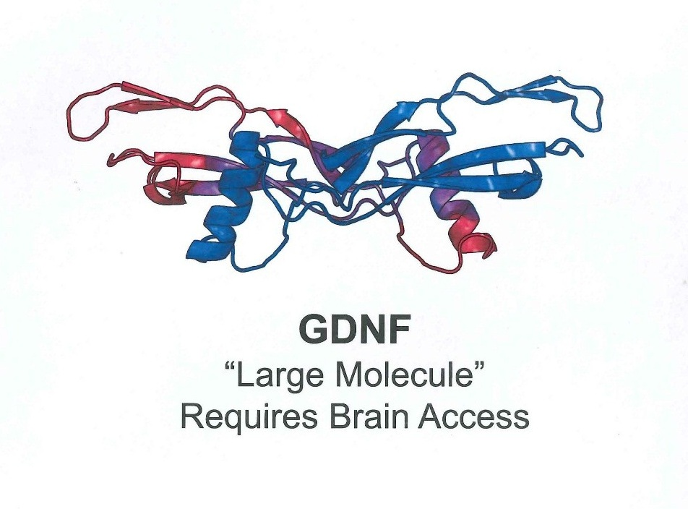

Source: Courtesy of Amgen.

Exhibit 3Summary of Amgen’s Randomized, Double-Blind Trial of GDNF in Parkinson’s

Disease

See Lang, A. E., et al., “Randomized Controlled Trial of Intraputamenal Glial Cell Line–derived Neurotrophic Factor Infusion in Parkinson Disease,” *Annals of Neurology* 59(3) (March 2006): 459-66.

Exhibit 4Background Information on GDNF: A Timeline

See <http://www.pdf.org/en/science_news/release/pr_1216665220>

Exhibit 5GDNF Administration Diagram

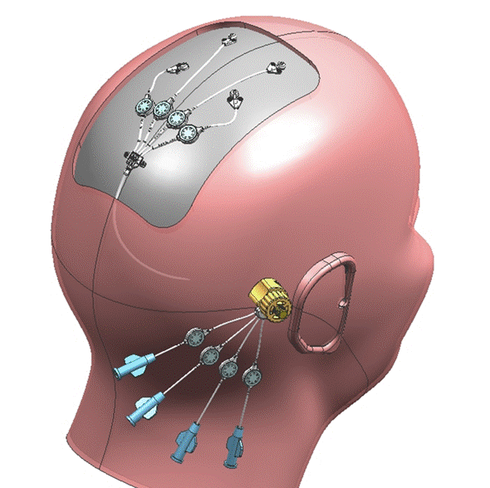

Source: Courtesy of Dr. Steven Gill, Frenchay Hospital and Spire Bristol Hospital.

Exhibit 6GDNF Treatment Model

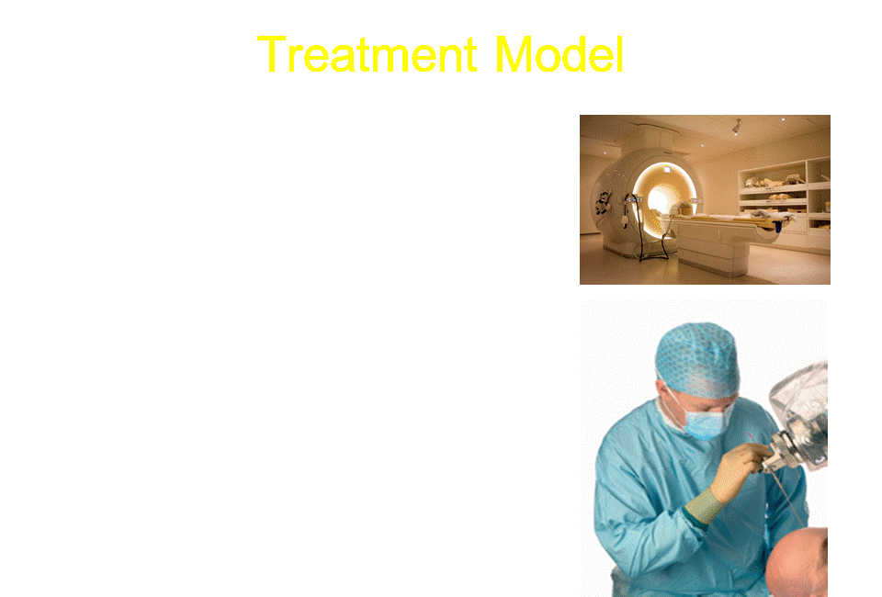

Source: Courtesy of Dr. Steven Gill, Frenchay Hospital and Spire Bristol Hospital.

Exhibit 7The Biopharmaceutical Research and Development Process

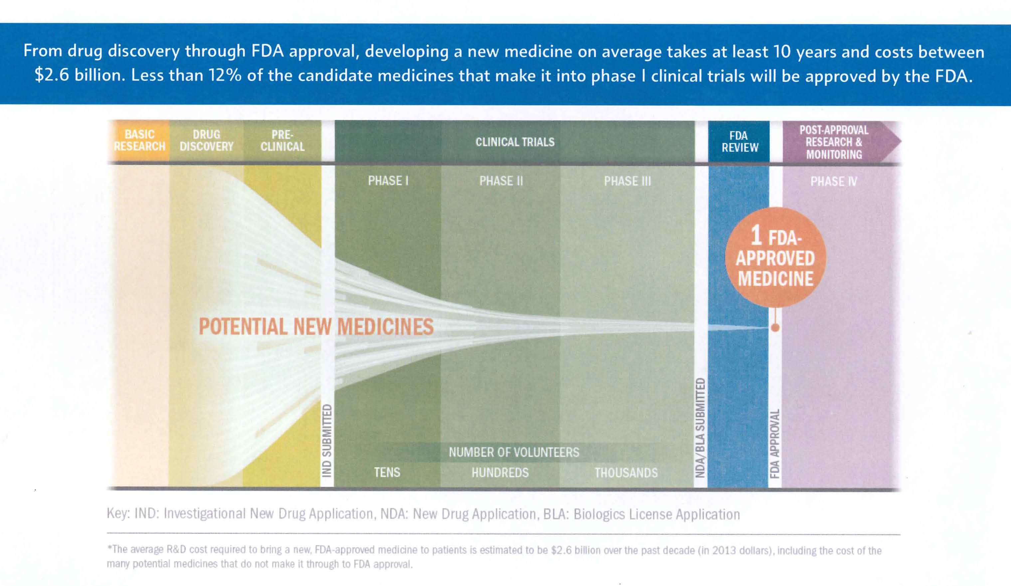

Source: Courtesy of Pharmaceutical Research and Manufacturers of America (PhRMA).

Instructors’ Guide for  
A New Therapy for Parkinson’s Disease

Introduction

This module is intended for use by business school students. The case elucidates under conditions of uncertainty the relationship between science/engineering and business opportunities to illustrate how an understanding of the science and engineering can reduce risk and enhance opportunity in business and impact development of a business case. This case could be taught depending on depth of discussion in either a 1-hour or 90-minute session. The 30 extra minutes in a 90-minute session would allow deeper probing of how best to structure a bid and advance molecule development.

Synopsis

Biotex is a fully integrated worldwide company facing an important decision. Peter Dillon, the chief executive officer, must decide whether to bid on a potentially promising therapy for Parkinson’s disease that is undergoing clinical trials at a smaller company. The smaller company has initiated with investment banking assistance an auction process to transfer development, production, and marketing rights to a larger company that has the resources, skills, and scale to fully develop the therapy and bring it to a worldwide market. There are uncertainties about the drug, including a previously unsuccessful development history in the hands of another company. Moreover, while the human testing results so far using the new injection system have been promising, the final registration-level results will not be available before Peter must decide on whether Biotex will bid. If Biotex waits for the definitive results, the auction will complete and the product will no longer be available. Peter must consider scientific, medical, regulatory, commercial, and financial questions as he considers what course to choose. Should this product succeed, it could be a very important advance for patients who have virtually no good choices currently as well as very attractive financial results for Biotex. If it fails, it would cost Biotex hundreds of millions of dollars.

Purpose

The case has four main purposes. First, it provides students the chance to analyze a rich and realistic description of a complex history of the scientific and medical results of a promising molecule and to consider whether it is worth further investment. Second, the students can dive deeply into the various possible explanations of why earlier trials failed and why the new trials with a different delivery mechanism might succeed. Third, the students can explore various ways Biotex might structure a bid and the trade-offs involved in various bid element choices. Fourth, the students can construct a best-case scenario for the further development of the drug involving investments, operational decisions, pricing, and regulatory and marketing plans. In pursuit of these four main learning objectives, the case should enable students to:

1. Analyze scientific and medical results that have been collected over time in order to recommend a future course of action.
2. List reasons why past trials failed and why a new trial might succeed.
3. Compare and contrast different ways in which Biotex might structure a bid, naming the strengths and weaknesses of each.
4. Prepare a best-case scenario that includes information about investments, operational decisions, pricing, regulations, and marketing plans.
5. Describe Parkinson’s disease, including who it affects and how it affects them.
6. Describe GDNF (glial cell-derived neurotrophic factor) and its relationship to Parkinson’s disease.
7. Draw a time line for events in the history of GDNF.
8. Name the steps of the drug development process.
9. Summarize the findings of nonhuman studies of GDNF.
10. Summarize the findings of Amgen’s Randomized, Double-Blind Trial.

Suggested Assignment Questions

1. How would you describe the prospects for GDNF? What makes you concerned and what makes you hopeful? Would you want to make a serious bid or not?
2. How do you analyze the possible benefits of the new injection system? Do you think this system is practical to use on a wide scale? How would you prepare the medical system to use such an injection system on a wide scale?
3. How would you structure a bid for GDNF? Financial considerations? Progress payments? Ongoing participation for medGenesis financially and in development? Other considerations?
4. What would be a development and marketing plan for the drug, including financial, development, regulatory, pricing, operation, and marketing considerations? What would you need to believe for this drug to succeed for Biotex?

Analysis

GDNF as a Therapy

GDNF is a molecule with a long history. It is known ex vivo to be a growth factor for neurons. There is also much evidence that it has a beneficial impact on growing and supporting neuronal networks, which are degraded in Parkinson’s disease. Early primate models were promising and small open-label studies had interesting and possibly positive results. The Amgen double-blind clinical trials in Parkinson’s patients failed, however.

There is a strong view in the minds of many current scientists and physicians that those Amgen trials were flawed in that the catheter-based system to deliver the drug across the blood-brain barrier was ineffective in that it did not deliver the proper amount of drug to the proper location. The current approach uses a different, more precise delivery approach, and there are indications that this approach could prove positive. However, the definitive trials have not been completed, and more clinical research needs to be done to answer definitively the question of whether GDNF works in Parkinson’s. There are questions of disease mechanism; GDNF as a therapeutic; delivery system and, to a degree, proper safety questions when GDNF at a very, very high dose was given to primates. This is a judgment call weighing a significant body of theory, evidence, and prospects. The “safe” answer is easy: no. But Biotex is in the business of making large, risky bets on incomplete data. Is this a wise bet or a fool’s mission?

Considering the New Injection System

The Amgen-sponsored clinical trials utilized surgically implanted catheters that delivered the drug directly into the brain with the aid of an external pump placed under the patient’s skin. The theory was that the drug would be delivered slowly to the target region in the brain with the objective of achieving the right dose at the right location. The catheters were carefully implanted, but the apparatus of catheter and pump was technology widely used and not purposely built for this application. A key question about the Amgen trials is whether this delivery system actually delivered the proper dose to the proper location, with some evidence suggesting it may not have been as precise as planned. Further, some experts concluded that the low-pressure differential allowed reflux convection that introduced additional anomaly into the test. Dr. Gill, an original GDNF Parkinson’s researcher, along with a large and capable UK high-tech firm developed a new high-pressure, multiport burst injection system that should overcome the shortfalls of the catheter system. A key factor for investors is to decide how likely they believe this new system will be to consistently and at large patient scale deliver proper dose. Moreover, the investor must consider the scalability and cost of establishing enough surgical centers worldwide should the drug work. Or, will a new system that is simpler, less costly, and able to achieve regulatory approval need to be developed to allow scaling to worldwide levels?

Structuring a Bid

Developing a bid structure is one of the two key business challenges in the case, with the other, building the business model that explores the range of value a successful drug could deliver or the cost of a failed drug trial or drug. This aspect of the case is not so much about precise numbers but in allowing students to structure a bid and in so doing consider the range of issues and their underlying drivers that need to be considered. The best way to begin is to ask the students to consider what does Biotex want and what does medGenesis want. Another aspect is to think about how much Biotex is willing to guarantee and how much is contingent. What has been the recent history for similar products? What are the contingent elements that will be included in the bid, for example, trial results, regulatory decisions, intellectual property awarded, sales achieved, profit achieved? How will development, manufacturing, regulation, pricing, marketing, and sales be organized and governed between the two firms? Is the big idea total Biotex control, a partnership, issue-by-issue or geography-by-geography splits? What is the range of choice and logic for each decision? What percent of the potential value creation of the product in low-, medium-, and high-outcome cases should Biotex be willing to share with medGenesis? The goal is to have students consider the elements, structure, choices, and implications and logic for various bid structures.

Building the Business Case

The total amount of guaranteed value and the risk potentially undertaken by Biotex depend on a considered determination of the possible upside and the total amount that must be risked and invested to realize the upside. The actual range of numbers that would emerge from such an analysis and the data, logic, and beliefs that underpin the results would strongly determine what Biotex is willing to bid. This part of the case is, again, less about a financial planning and analysis exercise, and more about structuring the problem to develop a way to proceed. What might be the total cost to win the bid and sustain the remaining investment to get the efficacy and safety answer? Suppose the current trial fails—would Biotex try another? If successful how long would it take to achieve mature market penetration and what percent of addressable patients would that be? How would the drug be priced by major markets, and if different, why? How are payers likely to react? Would we use direct to consumer advertising in the United States and at what cost? Who will pay for surgery centers and how many are necessary? What about manufacturing and distribution costs? Would we invest in additional IP development? What about competition? A good rule of thumb that can be given to students is that gross margin for biotechnology drugs can range from forty to sixty percent. Again, the instructor should focus on the elements of the analysis, how they might be determined, what the range of each element's outcome might be and what the range of profit that might result at maturity under various scenarios of efficacy, market penetration, and price. Ultimately, the students should be able to determine what Biotex would need to believe to deliver guarantees of $200 million; $500 million or more in the bid. Finally, how would Biotex explain to shareholders a winning aggressive bid that ultimately did not deliver value?

Discussion Questions

Context

1. Describe the dynamics of the biopharmaceutical business and their implications for Biotex and MedGenesis in considering the bid?
2. What are the key cultural aspects involved and their implications?
3. What are the risks to Biotex in this bid situation and how can Biotex manage these risks?

Prospects for GDNF

1. How do you assess the development and history of GDNF to date as well as the success of GDNF in Parkinson’s disease?
2. Assess the likelihood that GDNF will be a successful therapy. What process would you use to make this determination?
3. What makes it difficult to interpret the GDNF related data generated so far?
4. Was Amgen too hasty in abandoning development? How does the Amgen decision affect Biotex’s decision?
5. What will regulatory agencies want to see to approve the drug? What are the regulatory risks?
6. What are the other scientific, medical, or regulatory risks associated with making a bid and how would you proceed to as fully as possible assess the risks?
7. Would you bid? Why or why not?

Assessing the Injection System

1. What is your assessment of the Amgen trial catheter system? Do you find credible the view that it in effect compromised the trials?
2. Do you find the Gill system attractive and practical for widespread use if the drug works? What might be the major implementation challenges and how would you manage them?
3. What advances in delivery system or imaging would be most impactful to the use of GDNF as a therapy?

Structuring the Bid

1. What would you need to believe to license/purchase medGenesis?
2. How would you assess the risk elements of a winning bid to Biotex in regard to scientific, regulatory, market, competitive, financial, and other risks? The risk or cost to losing a bid? Would you bid? Why or why not?
3. What are the required inputs to develop a bid and how would you determine each element?
4. What is the upside financial case to Biotex? Downside?
5. How much value would you provide medGenesis up front? Why? How much would you share post launch, and how would you structure the method of determination—patients, profits, revenues, geographies?
6. How would you propose medGenesis participate in postdeal product development and commercialization? Why?
7. Any other bid considerations?
8. If the medGenesis trial succeeds, what would you need to do to fully develop the drug and what would be the challenges, costs, and risks?
9. Would you buy medGenesis? Why or why not?
10. How would you choose to commercialize the drug? For example, with partners or alone? How would you structure pricing?

The instructor will likely not have time to explore each question in the above list, but the question set hopefully provides a rich source of material to direct the class toward the day’s teaching objectives consistent with the class’s background and focus. The basic objective is to give the class a realistic experience in evaluating a complex, multi-element risk decision grounded in an assessment of scientific, medical, technical, regulatory, market, and financial factors. This case is realistic and represents the type of decisions senior leaders face in allocating resources to advance products in the face of scientific and medical uncertainty that could have profound benefit to society.