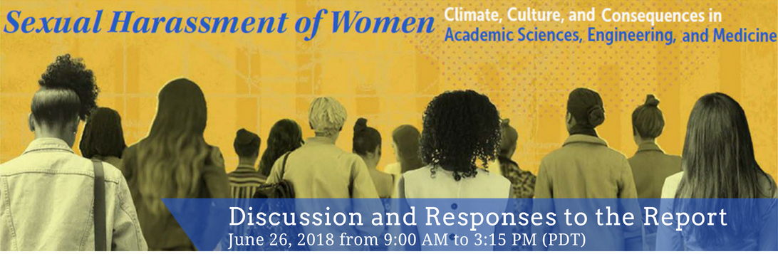

Subject: Discussion and Responses to the Report on Sexual Harassment in Academia – June 26th

How can academic institutions improve in the #MeToo era?

Join the National Academies of Sciences, Engineering, and Medicine on June 26th for discussion with leaders in higher education and those in entertainment, technology, medicine, and politics, about what actions can be taken to prevent sexual harassment. The discussion will revolve around a new report by the National Academies that presents a comprehensive review of the research, experiences, and effects of sexual harassment on women and their careers in science, engineering, and medicine. In addition to evidence-based findings, the report provides recommendations for how organizations can prevent and address sexual harassment in academic settings, specifically in science, engineering, and medicine.

Learn more and register for the event

Questions? Email shstudy@nas.edu
www.nationalacademies.org/sexualharassment
Join the Conversation Using #ScienceToo

