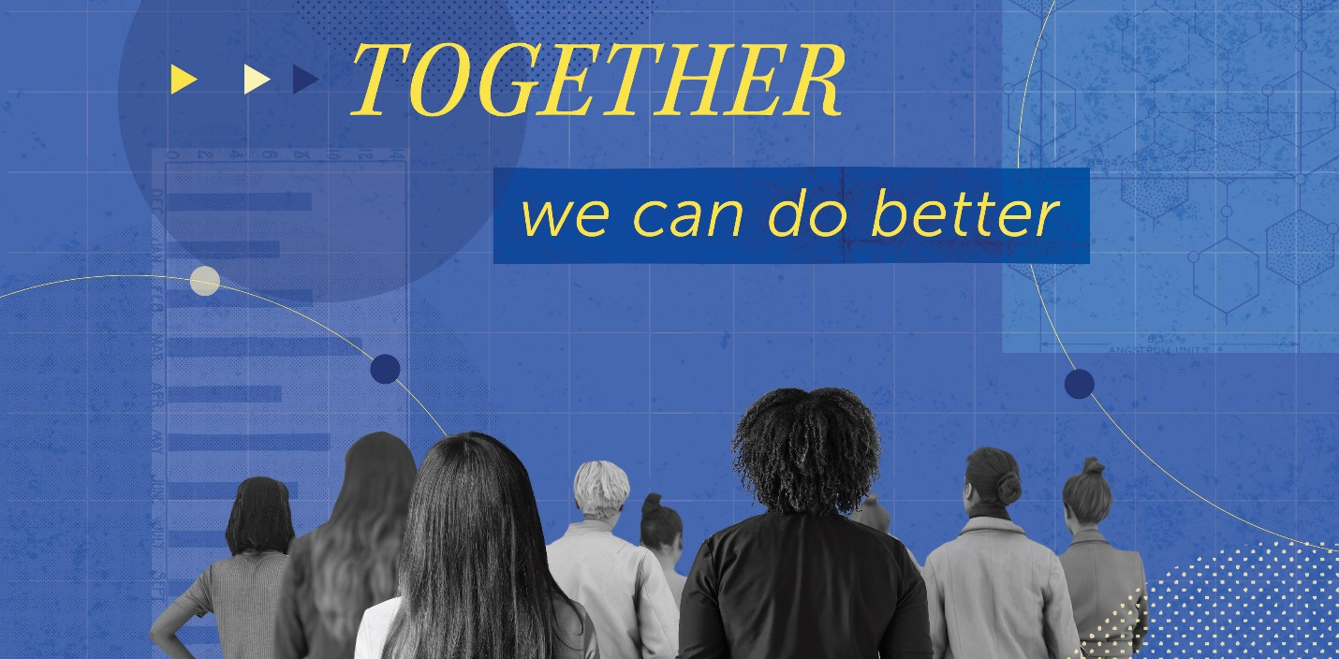
Together We Can Do Better
A National Convocation for Leaders in Academia on Preventing
Sexual Harassment
November 9, 2018
National Academy of Sciences Building
2101 Constitution Avenue NW
Washington, DC
Over the last two decades, important gains have been made in the participation of women in science, engineering, and biomedical disciplines at the undergraduate and graduate levels in the United States. More women than ever are also joining the faculty ranks in these fields and moving into leadership positions in higher education. While progress is slow, the reduction in the “gender gap” is encouraging. However, more rapid and sustained progress in closing the gender gap in science, engineering, and medicine is jeopardized by the persistence of sexual harassment and its adverse impact on women’s careers in our nation’s colleges and universities.
On November 9, 2018, join the National Academies of Sciences, Engineering, and Medicine for a convocation on developing and implementing policies, procedures, and practices to prevent sexual harassment in academia. Building on the recommendations in the recent report Sexual Harassment of Women: Climate, Culture, and Consequences in Academic Science, Engineering, and Medicine, this event will bring together academic leaders, Title IX and diversity officers, ombudsmen, researchers in sexual harassment, and leaders from professional societies, foundations, and federal agencies to discuss strategies and share promising practices.
With plenary sessions to inform and inspire change, breakout sessions to allow attendees to develop and strategize plans with colleagues and experts, and panel discussions to gather different perspectives and ideas, this convocation promises to be a platform for inspiring and initiating actions to change institutional cultures and climates in academia around sexual harassment.

Register to Attend

Short Version

The persistence of sexual harassment and its adverse impact on women’s careers in our nation’s colleges and universities is jeopardizing more rapid and sustained progress in closing the “gender gap” in science, engineering, and medicine. On November 9, 2018, join colleagues, leaders in academia, and other experts in building on the recent report Sexual Harassment of Women: Climate, Culture, and Consequences in Academic Science, Engineering, and Medicine, to develop and strategize plans on how to prevent sexual harassment in academia. Register to Attend

